Public Service Reform in Scotland

Dave Watson,
UNISON Scotland,
December 2016

The Author

Dave Watson is the Head of Policy and Public Affairs at UNISON Scotland. He is a graduate in law from the University of Strathclyde and a Fellow of the RSA. He manages the union’s policy, research, communications and government affairs functions as well as four organising teams. As a public sector trade union official for over 36 years, he has been involved in most of the public service reforms of recent times. 26 years in Scotland, but earlier in his career in England and Wales where he served on a health authority and other public bodies. He was an expert advisor to the Christie Commission and was also seconded to the Health Department to implement the new devolved government’s first HR strategy. He has written extensively on public service reform in the media an in other formats, and is a regular speaker at conferences on this issue. (d.watson@unison.co.uk)

Acknowledgements

I am grateful to my colleagues in the UNISON Scotland Bargaining and Campaigns Team who read and contributed ideas to this paper, in particular, Joy Graham and Kay Sillars. Also to the many colleagues, officials and academics I have worked with on this issue in recent years that have contributed to my thinking. Finally, my thanks to the many thousands of public service workers who do such a great job in increasingly difficult circumstances.

Contents
* Introduction
* Executive Summary
* The Case for Public Services
* Challenges Facing Scotland’s Public Services
* Public Service Workforce
* Approaches to Public Service Reform
* The Third sector
* The Christie Commission
* Scottish Approaches to Public Service Reform
* Financing Public Services
* Principles of Public Service Reform
* New Approaches to Public Service Reform
* Conclusion
* References

Executive Summary

- Five years on from the publication of the Christie Commission, with a Scottish Government committed to reviewing many aspects of public service delivery, it is timely to take a detailed look at public sector reform in Scotland. This paper outlines the public sector landscape in Scotland, looks at previous and current reform plans, and considers the options for further reform. While it does not offer a detailed blueprint, it does argue that there is another way between fragmented localism and command and control centralism.

- Public services evolved because of the failures of the market. The public also wanted a real say in how services are delivered rather than have what a group of volunteers thought they deserved. The scope and quality of our public services is the measure of a civilised society, but it is also the basis of a more equitable society and a stronger economy.

- Scotland’s public services face many challenges. The UK government’s austerity economics will cut Scotland’s budget by 12.5% in real terms by 2019-20. The Scottish Government has chosen to place the burden of that cut on local services, through disproportionate cuts to council grant allocations. Even the NHS, which has had some protection from the cuts, is facing significant financial pressures. Added to this we have a growing elderly population and a demand for services over and above demographic change. Scotland is also a deeply unequal society that public services should be addressing. All of this is compounded by the uncertainty of Brexit.

- People largely deliver public services, yet the workforce has often been an afterthought in public service reform. 31,000 devolved public sector jobs have been lost since the crash, 87% of those in local government. The remaining, ageing, workforce struggles to provide even statutory services while facing real term cuts to their pay, which in itself damages the local economy. The Fair Work Convention is a starting point for a new workforce framework that could support public service reform.

- The last forty years have seen the development of different approaches to public service reform worldwide, with governments blending command and control with devolution, transparency and quasi-markets. In the UK, New Labour governments used New Public Management to introduce targets and competition. Then New Public Governance recognised the role of citizens and democratic process, which led to the New Public Service approach with its emphasis on citizen engagement. Conservative governments have championed the role of markets, while sometimes using the language of mutualism.

- The voluntary sector plays an important role in the delivery of public services, employing around 138,000 staff. This is often confused with concepts of co-production and asset based approaches to service delivery. The sector is facing huge challenges from budget cuts, recruitment and retention of staff and criticisms of poor governance. Charities play an important role in society, but they should complement, not replace public services.

- The Christie Commission report on the Future Delivery of Public Services remains the basis for public service reform in Scotland. It identified the challenges facing public services and the importance of challenging inequality. It set out principles of integrated service delivery with staff and citizen engagement – based on local democracy not centralisation. Five years on, while the principles are often quoted, delivery has been patchy.

- Since devolution, Scotland has taken a different path to reform than in England. Co-operation rather than competition has been the mantra. While there has been some centralising structural change, notably Police and Fire services, the main focus has been on encouraging integration through Community Planning and ministerial powers of direction. Integrated joint boards for community health and care are the best example of this.

- The Scottish government has announced a number of reviews into the delivery of public services in its Plan for Scotland. These include structural reviews of councils and health boards as well as the management of schools and a voucher scheme for childcare.

- Not all reform has to be structural or legislative. Digital services are viewed as an important element of reform with initiatives like ‘My Account’ and UK and Scottish government strategies. However, digital exclusion remains a problem in many communities and big IT projects have a poor delivery record. IT staff have pointed to the reasons for some of the delivery failures.

- While outsourcing and shared services have not been used on the same scale as in England, almost a third of public spending goes to the private and third sector. The establishment of ALEOs have been driven more by tax dodging than effective service delivery and shared service plans have often been poorly managed, ignoring the lessons from high profile failures highlighted by the NAO and others. The Community Empowerment Act may also drive further fragmentation of service delivery.

- Any reform plan has to include how public services should be financed. Despite the political rhetoric around universalism, Scotland has a mix of universal and targeted services. Universalism on the Nordic model has many benefits, but there is only limited evidence that political parties are prepared to have the difficult conversation with the voters to deliver it. The same applies to preventative spending despite the cross-party consensus that this is the right approach.

- Every Scottish government since devolution has made extensive use of ruinously expensive PPP schemes. UNISON and others have shown how these could be refinanced or restructured and savings made from robust monitoring. Councils could be doing more to refinance borrowing and use local bonds. Council pension funds could also be used for socially useful investment if more efficiently organised.

- Local government finance needs radical reform instead of another round of tinkering with the system. The only practical solution is a progressive local property tax based on actual (not 1991) property values. This is politically difficult, but we simply cannot keep putting this off forever.

- There also needs to be difficult discussions around devolved taxation, now taxation powers have been devolved. Modest increases in tax would make an important contribution to improving public services and tackling inequality. There is some polling evidence that the public is actually ahead of the politicians on this. This also involves a debate on the future of the Barnett formula. It has served Scotland well, but being tied to English public sector reform decisions has medium term consequences.

- A new approach to public service reform should be based on a set of underpinning principles. This paper offers nine that all reform proposals should be tested against. Democratic accountability, subsidiarity, transparency, equality, effectiveness, fair work, integration, outcomes and a public sector ethos.

- Most reform measures start with central government and then consider what powers to devolve. An alternative approach is to start with people and communities and work upwards. Under current plans there is a real risk that local government is left to within on the vine, or at best becoming simply an administrative arm of government. An alternative approach is to start with recognisable communities and build service delivery from the bottom up. Community hubs could physically site services together, breaking down the silo mentality that Christie identified. Service design would be done with citizens and front line staff adopting ideas from Systems Thinking, The Enabling State, Participatory Budgeting and Co-operative councils. This would then form the basis for a debate on the best structure for local government to provide the essential democratic accountability.

- A revitalised local government could also promote new approaches to developing local economies using the ideas developed by the New Economics Foundation (Plugging the Gaps) and CRESC (The Foundational Economy). Councils could also rediscover municipal enterprise through community energy and use the re-regulation of buses to operate public transport.

- Scotland has over 100 non-governmental bodies that operate at arms length from government with no direct democratic accountability. In a country the size of Scotland it is not always possible to decentralise small specialist services and the ‘bonfire of the quangos’ tend to fizzle out. None the less, it is possible to improve accountability and join up services better at local level, linked to local government reform.

- The biggest non-governmental body is NHS Scotland and its network of health boards. The Scottish government is planning a review of health boards that is likely to reduce the number, leaving them with an acute focus, while community services remain with the IJBs. Other countries adopt an all-purpose authority approach joining these services with local government. However, a major imperative is to shift health resources from acute to community and this could be even more challenging if the services are structurally split. Structural change is the last resort for good reason, but equally the current health and local government structure does not reflect best practice elsewhere in Europe.

- The role of central government should be to set the strategic framework and arguably set minimum standards, but not detailed prescription. It is a feature of all governments that the longer they are in power, the more they believe they can direct services from the centre. Even in a country the size of Scotland that isn’t possible or desirable. However, in a small country it should be possible to agree frameworks that allow to local services to focus on service design without reinventing the wheel. A national workforce framework is a good example of this.

- In conclusion, the scale of the challenges facing public services in Scotland is immense. If they were challenging five years ago when the Christie Commission reported, they are even more so now. Advocates of reform tend to fall into two distinct camps – centralisers and localisers. This paper argues that there is another way. We should build public services from the bottom up based on the principle of subsidiarity, with integration, democracy and transparency at the core of delivery. The role of central government should be to set the strategic direction and agree frameworks that allow the local to focus on what matters. A co-operative more equal Scotland, rather than one left to the vagaries of the market. Who knows, Scotland may even become the go to place for effective public service reform in a small country.

Introduction

It is five years since the Christie Commission delivered its report on the Future Delivery of Public Services in Scotland. That report established the principles of reform and was adopted by the Scottish government with cross-party support. The new Scottish government has a manifesto commitment to undertake reviews that could lead to significant structural change in local government, NHS Scotland and schools.

In this context, it is timely to examine the progress of reform since the Christie Commission, the current challenges and the options for progressive change. Public services are under huge pressure as a result of spending cuts, exacerbated by demand pressures such as demographic change. This is a consequence of austerity economics that has the ideological objective of reducing the role of the state.

The approach of this paper will be to examine the context and development of public service reform in Scotland and to analyse the approaches of the current government and those who advocate other reforms. The paper will also make a case for change that recognises the value of public services to the economy and society generally. It will outline new approaches that contrast with the conventional top down solutions. Instead the paper will make the case for bottom up service design, accountable to local democracy in the broadest sense - while recognising that in a country the size of Scotland, there is a role for national frameworks and service integration.

This paper does not set out a detailed prescription for reform, although it does go further than basic principles. The aim is inform the debate about public service reform and argue that there is a better way.

The Case for Public Services

A nation's greatness is measured by how it treats its weakest members. (Mahatma Ghandi)

At the heart of austerity economics is a drive to reduce the role of the state and part of the strategy is to undermine public services. If voters don’t value services, then it makes it easier to make the cuts and introduce private provision.
Let’s start with some historical context. Public services as we know them evolved due to the failure of the community, voluntary and private sectors to meet the needs of the people. The infrastructure required both to support business and people to achieve their potential required co-ordination, local control and financial investment. While the well-off could buy many things for themselves, infrastructure and services like roads, schools, water supply and sewerage needed coordinated action and investment. Not only is it more efficient if everyone pays towards services, but everyone suffers when others do not do the right thing. A street where only half the homes were signed up to receive a fire service would be a street where every home would be at risk. The vermin attracted to a street where only half the bins are emptied would be a problem for everyone.
The reason why our services came to be provided through the public sector is that people increasingly wanted not just a service, but a say in what the services are. They did not want provision decided by what a group of volunteers thought they deserved. Until relatively recently, for many people ‘charity’ was a dirty word associated with what the great and the good thought that ordinary people should have or be doing: well-off ladies assessing your moral fibre before granting you a pittance. Voluntary/private service delivery had already failed.
Public service growth in the 20th Century was also about tackling inequality through fair and equal access to services. The OECD confirms that public services have a significant impact in reducing inequality:
Social spending in the UK relies more on public services (such as education, health etc.) than on cash transfers: spending on services amounts to over 15.4% of GDP while spending on cash transfers is some 10%. These services reduce inequality more than almost anywhere else, and this impact has increased over the 2000s.
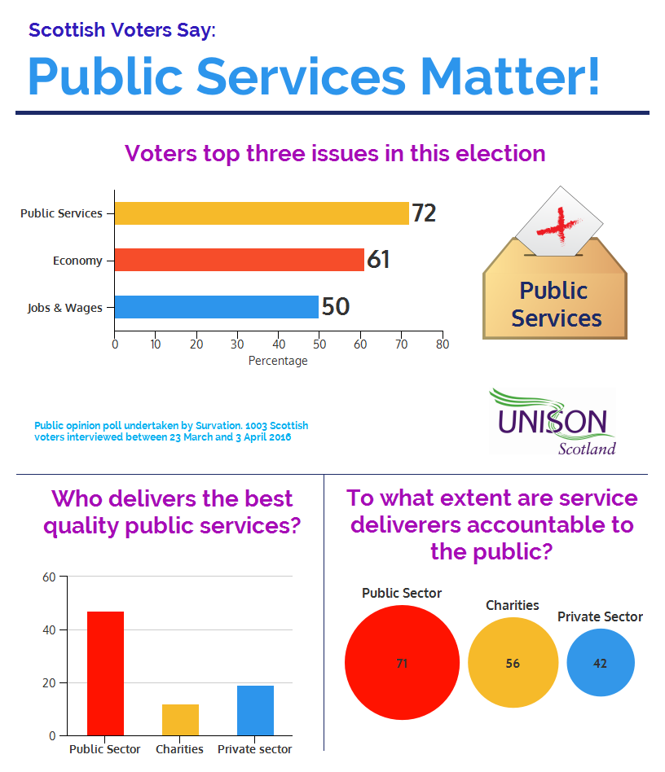
The public sector provides a means to both deliver services cost effectively and to allow citizens to participate in decision making and to engage with each other. This requires services to be designed through democratic processes to ensure that they meet the needs of all citizens not just those with the most money or power. Local Government has evolved because the infrastructure and services needed to support citizens and the economy could not be provided by the market or charities.
Despite the pressures on public services, they remain popular with the public. In this year’s Scottish Parliament election UNISON Scotland commissioned the pollsters Survation to undertake a public opinion poll on this issue.

72% said public services were in their top three most important election issues followed by the economy (61%) and job security/wages (50%). Labour and SNP voters’ priorities were almost identical. Conservative voters had the economy over public services and topically, the EU as their third top three issues.
The poll also asked who should generally deliver public services. 47% responded that the public sector delivers the best quality public services compared to the private sector (19%) and charities/social enterprises (12%). The public sector is also seen as the most accountable to the public (71%), compared to charities (56%) and the private sector (42%).

Challenges facing Scotland’s public services

First and foremost these are financial. The failure of austerity can be seen in the slowest recovery from recession since records began. While some progress has been made in balancing the budget, the period of austerity has doubled, largely due to sluggish growth and the consequential impact on tax revenues.

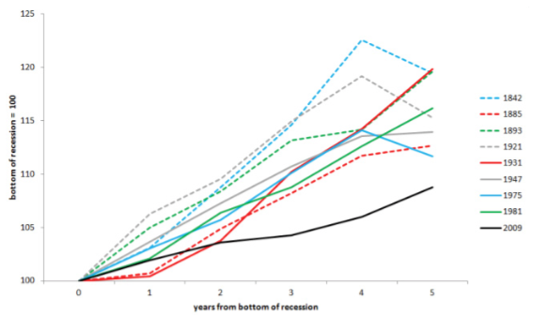
UK austerity impacts on the Scottish Government’s budget via the Barnett formula, which allocates a population share of (relevant) UK spending changes to Scotland.

The Scottish government’s latest estimate of the impact of UK austerity on Scotland is that the budget will, in real terms, be 12.5% lower by 2019-20 than it was in 2010-11, equivalent to a cut of £3.9 billion.

This is split between a cut to revenue (day-to-day) spending of £3.3 billion (-12%) and to capital (investment) spending of £0.6 billion (-22%). 8.7% (£2.7 billion) has happened, with a further £1.2 billion still to be imposed up to 2019-20. Within this total, capital spend is estimated to rise by £260 million, which means that day-to-day spending is to be cut by almost £1.5 billion. This is equivalent to a further 5.6% real terms cut to such spending to 2019-20, on top of the 6.6% cut already experienced from 2010-11 to 2015-16. In other words, 45% of the cut is still to come.

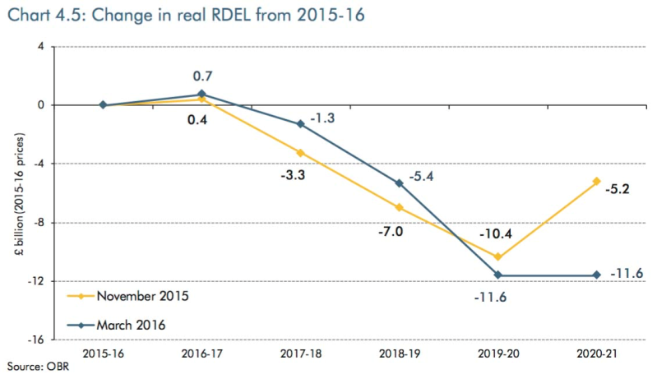
This is a higher reduction over future years (in percentage terms) than is seen for the UK (see OBR chart) due to a variety of factors, including the deferral of 2015-16 cuts to 2016-17 in Scotland and the way that UK devolved and non-devolved budgets evolve over time. For example, changes to the funding of English local government means that there could be no Barnett consequentials of local government spending by 2020.

The Scottish Government now has a range of taxation powers that could be used to mitigate austerity in Scotland. However, they have largely chosen not to use those powers. The 2016 SNP manifesto included changes to income tax thresholds that could raise £250m and tweaking the Council Tax that could raise £160m – neither of which will make much of a dent in UK austerity. They are also cutting taxes regressively with the proposed cut in Air Passenger Duty.

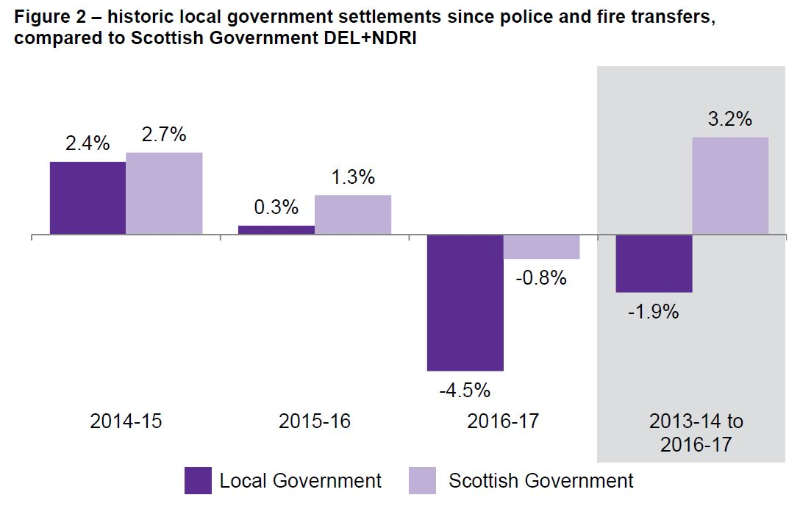
With selective, on-going, protection of some large budget services (NHS) in place, those services that are unprotected face very large cuts. As Professor John Maclaren puts it in his analysis of austerity in Scotland: ‘This could ultimately result in a public service landscape that is very different from the past and much narrower in its scope’.

While the overall Scottish budget is determined by the Barnett formula, the Scottish Government decides where the axe will fall. They have chosen to cut local government disproportionately as this chart from the Scottish Parliament Information Centre (SPICe) shows.

Between councils the impact has not been even. A study by the Joseph Rowntree Foundation has found that across local council services, in general terms:

- more rural councils have suffered more than more urban ones;
- poorer councils have suffered more than richer ones;
- these distributional impacts have been much more evident in England than in Scotland;
as the Scottish funding distribution system was less progressive than for England, this relative shift has led to a convergence between the two, towards relatively limited recognition of differential needs.

The health budget (mainly the NHS element) is the big budget gainer, with a £471m increase this year. The Scottish Government is also committed to an increase in the NHS revenue budget by £500m ‘by the end of this parliament’. This is a modest increase over five years that should be funded from the Barnett consequential of English NHS spending.

However, the increase in English health spending may not be all it seems. Professor Andrew Street at the University of York argues that the claimed £8.4bn increase in English spending by 2020-21 is actually closer to £4.5bn. The chart below shows how this spending might be increased each year and the average 0.8% looks very low. The modest £500m increase promised for NHS Scotland therefore looks like a pragmatic assessment of the Barnet consequentials.

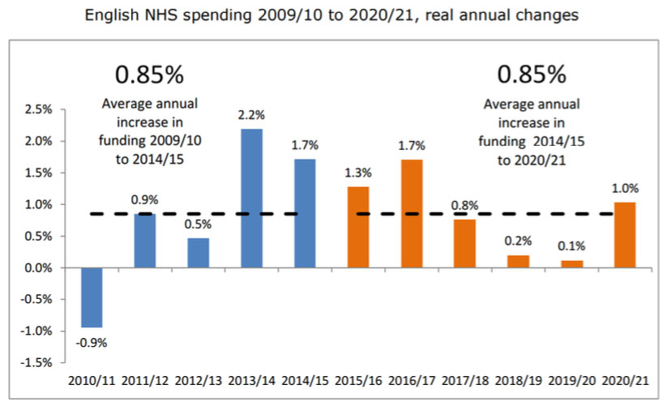
NHS England has highlighted a £30bn spending gap by 2020/21, of which the UK government claims to be providing £8bn.

Wage and drug costs; a growing and ageing population; and a trend in activity demand, over and above the demographics, explain the gap. There are similar pressures in Scotland. Even if our population growth is slower than England, we have an older population and poorer health that drives up costs.

For example, the NHS community drugs bill alone has risen to £1.3bn, a 6.9% increase last year and a 28% increase over the past decade. These increases are well above inflation and even the real terms increased outlined above.

It is not even clear that the changes in the budget due to changes in the relevant English spending (Barnett formula) will reach actual health board budgets, which are already under pressure. The SNP manifesto unhelpfully compounds the annual increase and claims it totals £2bn over the parliament. However, they are also committed to investing £1.3bn ‘from the NHS to integrated partnerships to build up social care capacity’. In England, councils are using a council tax increase to fund social care. In Scotland, there will be no Council Tax increase this year, and the increase from 2017 has been promised for education spending. This means health boards have to fund the cost of social care and increasing NHS demand from the same budget.

Austerity does not simply impact on public service budgets; it also fails to address the deep-seated inequalities that are arguably the biggest challenge to Scotland’s public services. The Christie Commission estimated that as much as 40 per cent of all spending on public services is accounted for by interventions that could have been avoided by prioritising a preventative approach. The Scottish Parliament Finance Committee also reported in 2011 on how public spending can best be focused over the longer term on trying to prevent, rather than deal with, negative social outcomes.

Demographic change is another significant challenge facing Scotland’s public services. Scotland’s population is continuing to age, with a 50% increase in over 60s projected by 2033. This growth is not geographically even. While 17% of the population is over 60, this age group makes up 21% of the population in several rural local authorities. Scotland’s dependency ratio is projected to increase from 60 per 100 to 68 per 100 by 2033. Age related public expenditure in the UK is projected to increase from 20.1% of GDP in 2007-8 to 26.6% in 2057.

While living longer is a good thing it will increase spending on services like health and social care. On the other hand, older people working longer will increase tax revenues and they will be important consumers of goods and services – growing the economy. They are also contributing to asset based approaches to service delivery, for example, in childcare and in voluntary sector provision.

The latest challenge to public services is Brexit. At present this contributes to uncertainty because the UK negotiating approach is unclear. The immediate concern is for the economy and the consequential impact any downturn has on tax revenues. Then there is migration, given the significant numbers of EU nationals who work delivering health and care services in particular. Longer term considerations include regulatory and environmental standards as well as the impact on research. In a ‘Hard Brexit’ scenario the UK will have to negotiate trade deals that could also impact on public services.
Public Service Workforce

Public services are generally staff intensive and as a consequence some 60% of all public spending goes on the workforce. Despite this, the workforce gets very little attention in public service reform, at best treated as an afterthought. For example, the consultation over the Public Bodies (Joint Working) Act that introduced probably the biggest reform to health and care for a generation, barely mentioned the workforce.
Workforce Numbers
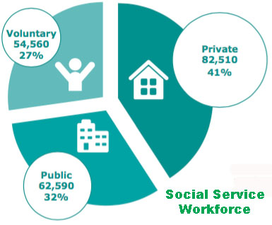
531,000 people work in the public sector, around one-fifth of the Scottish workforce. Workforce data in Scotland is generally poor, but the public service workforce is much higher than this figure when you take into account the private and voluntary sector providers. Although Scotland has not adopted privatisation to the same extent as England, a third of the Scottish budget is spent on external procurement.

The most significant privatisation has happened in the social service workforce. Nearly 200,000 people work in this sector (around one in thirteen of the Scottish workforce). Of these some two-thirds are employed in the private or voluntary sector, and as the SSSC report, this trend is increasing.

Headline public service workforce data is also unreliable because it rarely takes account of external leakages due to privatisation, and even internal transfers are difficult to track. 2009 was the first full year after the crash when staffing numbers fell in line with budgets cuts. Devolved public sector jobs have fallen by around 31,000 since the end of 2009 (allowing for transfers out). Over this period, (with the same transfers) local government has lost around 27,000 jobs – 87% of the total. The NHS has remained the same and colleges have lost just under 2000 jobs.

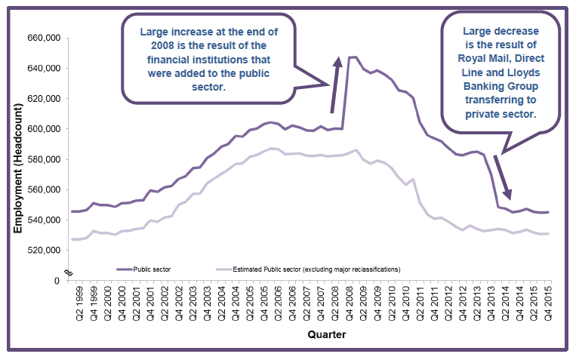
Looking back at historic trends, it is interesting to see how staffing levels have changed since devolution in 1999.

Overall public sector employment has increased by 13,400. The big gainer has been the NHS, with 31,600 extra staff. The big loser has been local government, with around 18,000 jobs lost. This allows for police and the other main transfers. Public corporations (that includes Scottish Water) have lost 2,100 jobs. Colleges have lost 1,800 jobs. NDPBs have gained 6,700 jobs on paper, but there have been a number of transfers and reclassifications in this sector. The devolved civil service has increased by 1,300 jobs.

Impact of workforce cuts

It's not just the number of jobs that have gone; we also need to look at the qualitative impact austerity has had on public services, particularly in local government.

UNISON Scotland has been publishing a regular series of reports in their ‘Damage’ series that use Freedom of Information (FoI) requests, and most importantly, surveys of members in different parts of the public sector – often those that don’t catch the public eye. They allow workers to tell their own story of the impact of cuts on them and the services they deliver.

While they all deal with specific services, there are common themes. The salami slicing of cuts leaves many staff juggling competing demands on their time. ‘Keeping the plates spinning’ is a common comment your hear from staff who are often moved around to plug gaps when backlogs get too large in another section.

Another is retrenching to the bare minimum statutory duties. For example, enforcement staff used to put a premium on education to help businesses and others with their statutory duties, but much of that has now been lost. Even statutory duties are cut back. When parliament was considering publishing environmental health reports in restaurant windows, UNISON had to point out that this was meaningless in many cases because they would be so out of date.

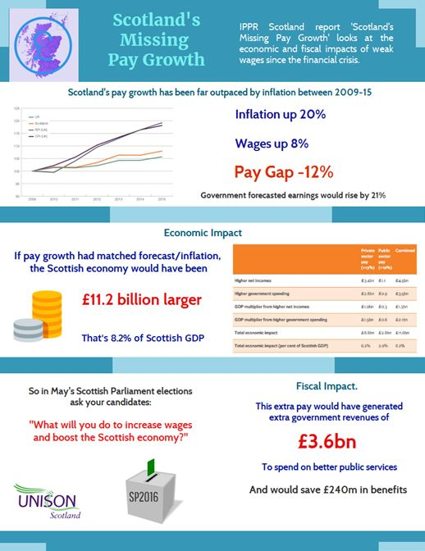
The impact of cuts on the workforce is also clear from the surveys. Staff doing large amounts of unpaid overtime, increased levels of stress related illness and concern for their clients over the corner cutting they are forced to deliver. They paint a depressing picture of a committed, yet demoralised workforce. Nowhere is that clearer than in the social care workforce. The recent report ‘We care, do you?’, includes many quotes from workers frustrated by the poor quality service they are forced to deliver.

Pay and Ageing

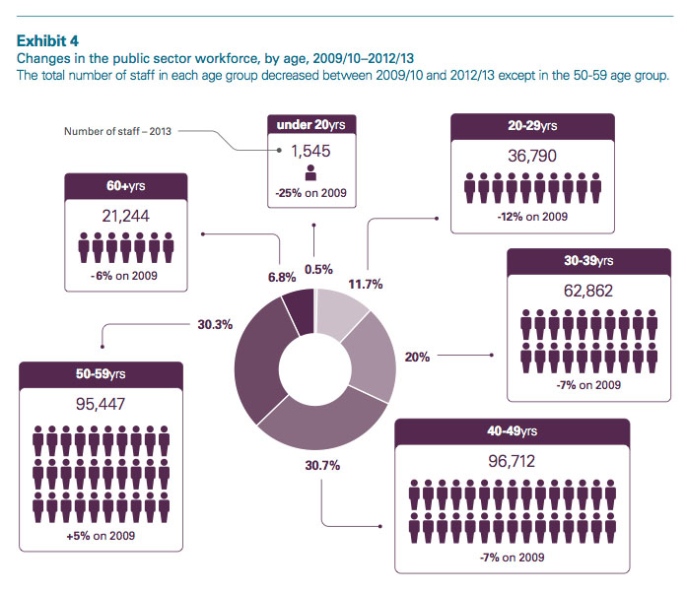
These concerns are compounded by significant real terms cuts in public sector pay. As a recent IPPR report shows, public sector wages in Scotland are 10% lower than even the UK government projections. This is not only a significant impact on individual, often low paid workers, standard of living, but it has also damaged the economy. The IPPR report calculates that Scotland’s economy would be £11.6bn, or 8.2%, larger than it is. The missing pay from the public and private sector would have generated £3,6bn in additional public revenues.

Another little understood impact of the cuts is the ageing public sector workforce. Proportionally, the only growing section of the workforce is the 50 to 60 year old range. Very few young workers are being recruited and this will lead to significant problems in the years to come. Very little workforce planning is undertaken in the public sector and that which is undertaken tends to be limited to a small number of occupations.

In summary, people, not robots, deliver most public services. This means a highly motivated, fairly remunerated workforce is an essential element of public service delivery.

Workforce framework

That isn’t the current position, so what can we do about it?

The Scottish Government’s Fair Work Convention is a step in the right direction. It sets the tone for good employment practice in Scotland and uses a number of public sector examples, such as the NHS Scotland partnership structures, to illustrate best practice. The challenge for the convention and the Scottish Government is to turn these words into action as Professor Gregor Gall highlights in his Reid Foundation paper. The Scottish Government has a number of levers it could use to promote the convention framework, including public sector pay policy and procurement.

In the public sector the Scottish Government could go further. While in general this paper will argue for a localism approach to public service delivery, it has to be accepted that in a country the size of Scotland we should not be continually reinventing the wheel. For example, do we really need hundreds of different workforce procedural agreements?

One of the frameworks that could support localism is a public sector workforce framework. In the short term this could include:

- A public service staff governance charter that would provide common standards across all public services and set out a common public service ethos.
- Develop common procedural agreements as part of the staff governance framework. This would obviate the problems created when staff from different employers operate under different procedures (discipline, grievance etc) in joint teams.
- A legislative framework for staff transfers to ensure consistency and to avoid the need for staff transfer orders in every public sector reorganisation.
- A similar provision to deal with pension transfers.
- A secondment framework that would allow temporary transfers between services.
- Review and merge procurement guidance including shared services, s52, PPP protocol etc into one common provision applying to all public services.
- A common framework on the application of equality duties.
- A coordinated approach to workforce development, including a common competency framework and inter-disciplinary training programmes.

The Christie Commission introduced the concept of the single public service worker and that this need not be limited to those directly employed in the public sector, but could include all those who can adopt a public service ethos.

The measures above should be the start of a journey that could result in a genuine single worker, on common terms and conditions. Given the significant, and frankly often unnecessary differences across the current workforce, this would be a challenging goal to negotiate. However, the gains would be huge and could be achieved on an incremental basis.

Approaches to Public Service Reform

We trained hard, but it seemed that every time we were beginning to form up into teams, we would be reorganised. I was to learn later in life that we tend to meet any new situation by reorganising; and a wonderful method it can be for creating the illusion of progress while producing confusion, inefficiency, and demoralisation. (Attributed to the Roman General Gaius Petronius)

There has been a considerable amount of academic discourse on public service reform since the 1980’s. These identify different models as pursued, in full or in part, by governments in the UK and internationally. This paper will not attempt to cover these in any detail, but a summary may be helpful to identify if they offer any new approaches for Scotland.

It is argued that in a globalised, consumerist world, public services have to respond by providing more and better services to consumers who don’t want to pay higher taxes. Public services have to be good enough so that the wealthy use them, or at least see their value. Otherwise they vote against them and public services become simply a safety net for the most disadvantaged. We can see this in public opinion polls that give the NHS very high approval ratings, because almost everyone uses it. In contrast, council housing gets a much lower rating because most people don’t live in them and they are often spatially segregated.

Michael Barber from the management consultants McKinsey argues that leftist solutions emphasise equality at the price of uniformity, while rightist solutions offer diversity at the price of inequality. As neither of these philosophies offers a total solution, he offers three paradigms for public service reform, using UK and international examples, showing how governments have tried to blend these two philosophies – with mixed success. His three paradigms are command and control; devolution and transparency; and quasi-markets.

New Public Management

This attempt to blend philosophies is perhaps best illustrated by the post-1997 UK Labour Government, which in England at least, attempted to do this with what they called ‘self improving systems’:
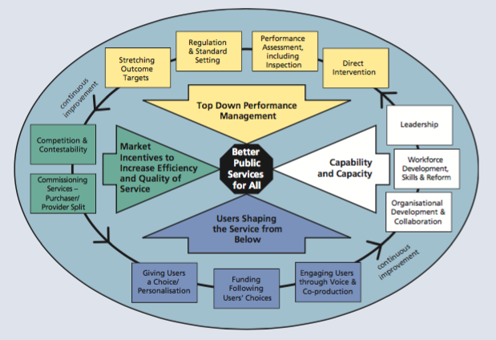
The Government’s approach seeks to create ‘self-improving systems’ which combine government and citizen pressure for improvement, competitive provision and measures to improve the capability and capacity of civil and public servants and central and local government. It is a ‘self-improving system’ because incentives for continuous improvement and innovation are embedded within it.
This approach led to the target driven contestability regimes of the Blair government, also known as New Public Management. There are many reasons while this approach failed, not least because top down performance management from Whitehall (Prime Minister’s Delivery Unit) was always going to be problematic. The work of John Seddon and others explains why. The latest report from the Glasgow Centre for Population and Health indicates that many of Scotland’s health problems have been caused by delivering and designing programmes ‘top down’ rather than in partnership with those who have to live with the consequences.

New Public Governance

The weaknesses in market driven and top down systems are addressed in the concept of ‘New Public Governance’ or ‘Public Value’. This approach argues that public services are distinctive because they are characterised by claims of rights by citizens to services that have been authorised and funded through some democratic process. Public value is the analogue of the desire to maximise shareholder value in the private sector. This leads to greater dialogue with service users without taking an ideological view on delivery. The theory is ‘what matters is what works’, viewed through the lens of the principles of equity and accessibility. Importantly, objectives are set at local level, not through national targets.

New Public Service

This is developed in the New Public Service (NPS) approach. This approach argues that citizens should be taken beyond narrow self-interest to the wider public interest and the role of public officials is to facilitate opportunities for strengthening citizen engagement in finding solutions to societal problems. It is reflected in later approaches developed by the last UK Labour government in what became known as ‘New Localism’. However, the ideas were undermined by the centralising reform tendencies of Whitehall - tendencies that are sadly not totally absent in St Andrew’s House.

This leads to the development of co-production and asset based approaches that encourage shared responsibilities. The use of new technologies through digital governance is another way of engaging citizens. We explore these issues later in this paper.

Mutuals

The 2010 UK coalition government used the language of co-operatives to extend the market into public services. They claimed this would empower public service workers to become their own boss. Conveniently ignoring the needs of service users or the realities of pitching small businesses into a market pool full of very large well-financed sharks. They introduced ‘Modern Commissioning’, ‘Community Right to Challenge’ and ‘payment by success’ to encourage greater marketisation and privatisation.

However, The idea of mutualism has broader support and appeared in all the UK parties’ 2010 manifestos. Steve Davies, in a report for UNISON, explores the idea that mutuals, co-operatives and social enterprises could deliver public services.

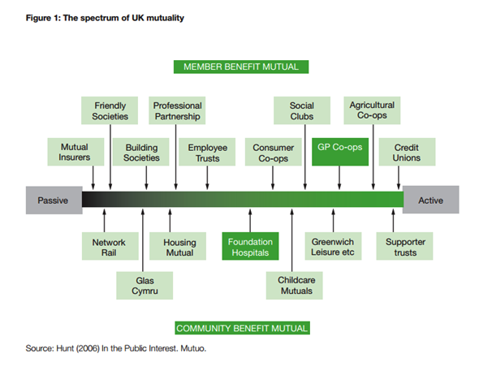
He reminds us that this approach is based on a market approach to public services. This needs an oversupply of services and an acceptance that mutuals can be driven out of business or taken over by profit driven firms. He sets out the range of practical difficulties mutuals face in this type of market.

There is a certain irony, given the failure of the private sector in the crash that it’s the public sector, not the private sector that the government wants to encourage mutuals to engage in. This points to the real agenda – shrink the state and marketise the service provision that is left.

Davies concludes that there is no reason why mutual virtues should not be present in all public sector provision and in the best parts of the public sector, they are. Equally there is no reason why outsourcing and marketisation are necessary to achieve this. That does not mean that mutuals could not play a role in public service provision and indeed he sets out some mechanisms and tests for any programme.

Conclusion

Since the 1980’s there have been many attempts to move public services away from the traditional forms of public administration, characterised by command and control systems with limited discretion for officials and minimal public engagement. New Public Management used a mixture of market systems and performance management to achieve results. While this remains a common model, New Public Governance and New Public Service approaches, together with ideas like mutualism have tried to address the failures of NPM with a more ‘bottom-up’ approach.

While these are neat academic descriptors, in practice governments and public bodies use elements of all these models.

The Third Sector

Charities and the wider third sector play a significant role in Scotland at many levels. There are some 45,000 voluntary organisations in Scotland, with assets of £8.6bn and an annual income of £4.5bn. They employ 138,000 staff (83,350 WTE). Encouraged by the Scottish Government; they are also playing a larger role in the delivery of public services.

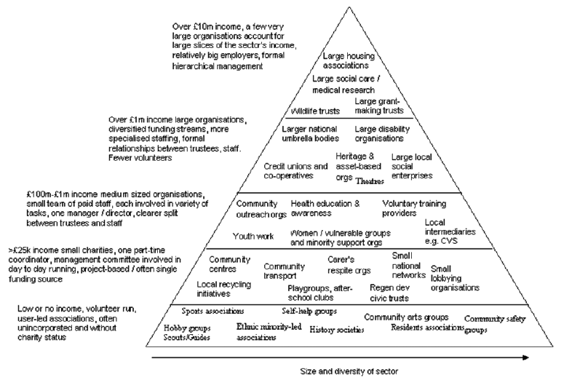
A strong charity sector plays a key role in any civilised society and any decline would make our society poorer. However, that should not close our eyes to the sector’s faults. From aggressive fundraising practices, to mismanagement, poor employment practice and corporate pay levels – the governance of many charities has been challenged.

Employer of choice?

In just three years, the number of charity chiefs paid more than £60,000 has risen by 26%. Bosses at Quarriers, Capability Scotland, Scottish Autism and Scottish Association for Mental Health all earn yearly wages of around £100,000. As Scottish Conservative MSP Alex Johnstone put it rather bluntly: ‘While fat cat charity bosses are coining it in, many ordinary people who generously donate in good faith feel like they’re being robbed. Donations should be used to support worthy causes not fund luxury lifestyles for executives.’

The third sector likes to view itself as the employers of choice and some charities do live up to that standard. However, many others clearly do not. A survey of voluntary (not redundancy) resignations, showed that the not-for-profit sector had the second highest turnover behind the notorious hospitality sector. It was also almost twice that of local government.

Pay and conditions is certainly a factor and poor commissioning largely drives the problems here. Particularly in the care sector where many third sector providers are struggling to recruit and retain staff, with turnover rates as high as 50%. However, many care staff are just as likely to refer to poor management as pay.

Governance

The infamous case of Kids Company raised many concerns about the role, competency and accountability of charity trustees. In fairness, this was a point that even SCVO acknowledged. Scotland has not been exempt from similar problems. Trustees, there are 180,000 of them in Scotland, lead their charity and have overall responsibility for how they are run. With more and more public services delivered by third sector organisations, including charities, charity trustees must be competent enough to provide oversight and be accountable for public monies they spend.

Charities, even those who receive most of their income from the taxpayer are exempt from Freedom of Information laws. Government needs to change this, but they have so far refused, in part due to a lobby from the charity sector. Resisting public scrutiny damages the sectors credibility. There was a similar position in relation to the Lobbying Bill, with a strong lobby to exclude the charity sector.

The Scottish charity regulator OSCR last year published its report on targeted regulation. Its proposals can only be described as modest - focusing on publishing accounts, creating a trustee database and serious incident reporting. Many feel that this is inadequate and very light touch regulation.

UNISON’s submission questioned if some organisations have moved so far away from their original charitable purpose, that they should be reclassified as social enterprises. MPs on the Public Accounts Committee looked into the Kids Company and concluded that there is a need for a radical change in charity regulation.

In Scotland, a number of care charities in particular, need to review their management structures, grading systems and support staff. There needs to be better cooperation over training and other services. As others have argued a transformation to ‘smarter working’ can be done without shedding essential frontline jobs or services.

In a 2014 survey, when asked whether most charities are trustworthy and act in the public interest 71% of people agreed, a figure broadly in line with previous years. In 2015, this had fallen to just 57%. In light of so many negative, high-profile stories, this is perhaps unsurprising.

Many charities are over-reliant on government funding. IPPR North’s research paper, Too Small To Fail, warned that smaller charities – specifically those with incomes between £25,000 and £1m – face a double whammy of rising demand and a sharp reduction in government income.

Reliance on government money can also undermine the advocacy role of charities. Sometimes this is subtle self-regulation because charities are concerned that criticism of governments or other public bodies might impact on their funding. For that reason a number of charities who retain advocacy roles, limit the amount of taxpayer funding that they will accept.

Role in service delivery

For some in the voluntary sector, hostility to the public sector runs deep. Martin Sime, Chief Executive of the Scottish Council for Voluntary Organisations, commenting on the Brexit vote said; ‘Those who have cried wolf too often about public sector austerity - which has barely scratched the surface of our bloated public sector in Scotland - will shortly discover the costs of this mistaken, damaging and profoundly unwelcome decision’.

Martin Sime’s own model for public sector reform involves abolishing councils and replacing them with self-directed support, he said: ‘Self-directedness is more than a new way for organising social care - it speaks to a basic tenet of voluntary organisation - people need to feel a sense of control over their own lives if they are going to succeed’.

His model disposes of local democracy in favour of a new form of the Tory voucher scheme. It would create the very 19th Century form of fragmented public service delivery that local government was established to fix.

There is wider agreement that good locally based voluntary organisations are well placed to achieve some of the health and care goals which are crucial to the sustainability of our NHS and social care systems. They can support groups and communities that are otherwise neglected, not only responding to health needs but also starting to address the social determinants (poverty, housing, exclusion) of health and deep-rooted health inequalities. Traditional contracting models are not helpful in developing these organisations.

Charities play a vital role in our society and can, within a new public service settlement, play a role in public service delivery. However, they should complement not replace directly provided public services. In addition, if they are to recover public trust and the support of staff, they need to improve their governance. Government also needs to strengthen regulation and transparency and provide a longer term fair funding framework.

The Christie Commission

The Scottish Government established the Commission on the Future Delivery of Public Services, chaired by Campbell Christie, former General Secretary of the STUC. The commission had a broad remit to look at the long-term pattern of public service delivery in Scotland. The focus was on the underlying principles of reform, rather than detailed structural change. It also demonstrated a very different approach to reform in Scotland compared to the approach in England.

Commission findings

The Commission reported in June 2011 and its key conclusions were that Scotland’s public services require comprehensive reform by empowering communities, integrating service provision, preventing negative social outcomes and becoming more efficient. The principles in this report have formed the basis of public service reform in Scotland over recent years.

The report starkly set out the financial challenges facing Scotland’s public services. While the actual cuts have been even greater than Christie predicted the prediction that spending levels are unlikely to return to 2010 levels for 16 years, taking £36bn out of Scottish budgets, still looks broadly correct. Christie also identified that the demand for services will rise due to the economic downturn and a growing elderly population, and estimated that as another £27bn.
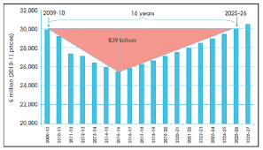
Equally important to the Commission was growing inequality between the top and the bottom 20% in outcomes such as income, employment and health. The consequences of disadvantage impose financial costs on public services, estimated at 40%+ of local public service spending.

The report recognised the crucial contribution public services make to the Scottish economy and tackles the myth that public services are a drag on economic progress. Nearly a third of the Scottish budget goes in procurement to the private and third sectors and public services play a key role in improving the business environment.

The Commission analysed how Scotland’s public services are placed to respond to these challenges. It identified problems including fragmented authority and operational duplication, coupled with a top down approach that designs services for individuals rather than with them. Accountability and transparency was often unclear with services tackling short-term symptoms rather than the underlying causes.

The recommended solutions start with positive approaches that allow services and communities to work together to decide what needs to be done making best use of all the resources available - taking a long term, preventative approach. Staff should be empowered by leaders to actively seek innovative solutions with a ‘can-do’ attitude. Several case studies illustrate positive approaches in action. These include personalising services to individuals, including personal control of a budget (self-directed support), although the report states that other options must remain available and it is not appropriate for all care services. Building services around communities is a key feature of the report, defining ‘community’ as place based and interest based - an important distinction that is often lost in the localism debate.

The section on workforce recognised the key role of all staff in the transformation of public service delivery. The Commission recommended that this should be built on a strengthened public service ethos based on enabling and empowering the lives of people and communities. This should be a core competency for all staff delivering public services and built into common training. Staff engagement should lead to staff doing work that is understandable, manageable and meaningful. Bottom-up systems thinking is an approach highlighted in the report, illustrated with a case study that highlights the dangers in splitting front and back office delivery.

The commission’s second key solution is that public service organisations work together effectively to achieve outcomes. Different accountability frameworks, statutory duties, performance management, different funding arrangements and short-term objectives have hampered outcome-based approaches.

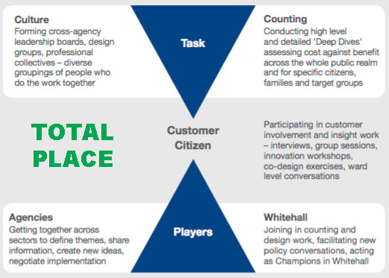
The report recommended a new approach that requires and incentivises organisations to deliver an integrated pattern of service provision for an area. This involves agreed common local outcomes at the community planning partnership level and in each locality. These outcomes will be influenced by national outcomes, but developed locally with people and communities. To ensure this happens there should be common powers and duties on all organisations, plus budgetary flexibility and sharing to reflect the totality of spending in an area. The commission was particularly impressed by the Total Place initiative in England that now appears to have been absorbed into Community Budgeting.

At a national level the commission recommended that policy direction needed to reflect this new approach dealing with the tensions between national targets and local outcomes that have constrained this approach. The overall aim was that all public service organisations operating in a local authority area should view themselves as part of a common framework for public services, developing a common identity and branding e.g. ‘Public Services South Lanarkshire’. These organisations will then be judged on how they contribute to achieving the common outcomes for the area.

The next solution in the report is that public services should prioritise prevention, reduce inequalities and promote equality. The key to this is adopting preventative approaches like early interventions that prevents the negative outcomes and take demand out of the system over the longer term. Inequality is the biggest barrier to the aspiration that public services act as a force for social justice and human rights. This should include pooling budgets and shifting spending from ‘reactive’ expenditure. The new powers and duties should include a specific presumption in favour of prioritising preventative action and reducing inequalities. Public services should also be targeted on the needs of deprived communities using highly localised data, bringing together all resources. The report also recognised that promoting equality is also about tackling discrimination and that includes taking seriously the public sector equality duty to address equality gaps in Scotland.

The last key objective in the report requires that all public services seek to improve performance and reduce costs, and are open, transparent and accountable. This was to be achieved through greater transparency surrounding budget decisions, showing how money is spent to achieve better outcomes. Plus better comparable data and wider use of benchmarking.

The commission was not tasked to recommend structural change. However, it did note that while Scotland has a complexity of organisations at a local level, it also has the lowest number of councils for its population of any European country. Government is encouraged to develop the ‘single public authority’ model (it was a live option in the islands at that time) and a rolling programme of bottom up reviews to improve performance and reduce costs.

The Commission’s report was widely welcomed and adopted by the Scottish Government. There were criticisms that it was weak on hard solutions. It is true that it deliberately avoided some contentious political issues like the council tax freeze, universal services etc. The Independent Budget Review Panel chaired by Crawford Beveridge had looked closely at these only a year earlier and so it would have been pointless to replicate that work. The Commission argued that these are political decisions and politicians are rightly accountable to the electorate for them.

Despite these criticisms the Christie Commission report is more radical than it first appears. Even if Scotland’s public services didn't face huge financial pressures there is a compelling case for tackling some of the country’s deep-rooted problems. This was the first time anyone had looked across Scotland's public services, instead of a particular silo, and recommended a different way of working. The recommendations were mostly about rewiring the system, but it was recognised that could lead to longer-term structural change - based on local democracy, not centralisation.

Christie five years on

It is now five years since the Commission reported. It is therefore reasonable to ask what progress has been made.

As identified in this paper, the challenges facing public services in Scotland today are remarkably similar to those identified by Christie, although if anything even greater. Austerity cuts have gone on longer than Christie predicted, largely because of the failure of austerity economics - creating the longest recovery from recession on record.

Scotland’s deep-seated inequalities remain largely untouched and recession has hit the most vulnerable hardest. Demographic change has only partially been alleviated by increased migration and even that is under threat by Brexit.

Christie had much to say about the role of the public service workforce in delivering reform. However, with 31,000 fewer devolved jobs, 87% of them coming from local government, the capacity to contribute is massively reduced. As UNISON and other surveys show, a demoralised, ageing workforce has been largely forced to abandon the preventative work Christie promoted. Instead, reverting to the statutory minimum, and sometimes not even that.

On outcomes, we have a nice website and some fine statements of policy intent, but politicians still emphasise inputs. As the head of CIPFA pointed out at a recent conference, the main SNP manifesto commitments were on spending or staff numbers, without any explicit link to outcomes. A fault it has to be said that is not limited to the SNP manifesto.

There remains considerable support for the concept of preventive spending. For example the Fire and Rescue Service can point to where fire prevention has reduced fires by 40%. However, generally there is considerable frustration over the barriers to preventative spending. Most obviously, that spending in one area might reduce the demand on another without giving any credit to the originating budget holder. The silos that Christie sought to bring down are very much in place.

Another Christie recommendation was for greater public service integration. Efforts are being made to achieve this in the key health and care field, but there is considerable scepticism that this will work. There are some good if isolated examples of progress, but there hasn’t been a wholesale culture change.

There are even fewer examples of bottom-up service design. Recent public service reform has championed centralisation and ministerial direction over the principles set out in Christie. There has been a decline in the use of top-down management consultants, with their Blue Peter ‘here is one I prepared earlier’ approach. However, that may have more to do with budgetary constraints than culture change.

Overall, while the principles of the Christie Commission report are still regarded as the way ahead, delivery has been patchy at best.

Scottish approaches to public service reform

I have not seen any evidence that people want choice. I see plenty of evidence that people want services that work. John Seddon

Cooperation not competition

While the Christie Commission set out new principles for public service reform in Scotland, a different approach to that south of the border had already been adopted by the early Labour administrations. Not always to the joy of the Blair government.

This different approach is best illustrated in the structure of the NHS in Scotland.

Following the 1997 general election Labour came into government and quickly initiated the devolution referendum that resulted in the first devolved administration in 1999. In April 1999 they set the path to reform by halving the number of NHS trusts in Scotland from 47 to 28 – making it clear that the market was not the future for health care in Scotland.

Important steps were taken to build cooperation in the NHS rather than competition. Market testing was dropped and services started to come back in house. This included a new HR strategy that introduced partnership working into the NHS. A model that survives to this day and has been rated as probably the best of its type in the world.

At the end of 2001, Malcolm Chisholm took over as health minister and introduced the NHS Reform Act of 2004. This Act formally abolished trusts, transferred services back to health boards and established a duty of cooperation. We had Community Health Partnerships for primary care and staff governance was given a statutory footing. Later, the government even brought Golden Jubilee Hospital, into public ownership.

Health ministers like Susan Deacon, Malcolm Chisholm and Andy Kerr, supported by the wider cabinet, made important decisions on a cooperative approach to public service reform despite political pressure from elsewhere. Subsequent SNP administrations have continued this approach and strengthened it with, for example, the rejection of commercial companies running GP practices. When we see what's happening to the NHS in England, we should remember to say, thanks very much for devolution and those early government decisions.

Structural Change

The approach to public service reform since the early changes noted above has largely been one of promoting joint working rather than major structural change.

The 32 unitary local authorities created to replace the two-tier regional and district councils have remained unchanged since 1996. Health boards, other than the merger of Argyll and Clyde with Glasgow, have also remained largely the same.

The next largest groupings of public service organisations are public bodies directly accountable to ministers and through ministers to parliament. These include Executive Agencies, Non-Departmental Public Bodies (NDPB) and public corporations like Calmac and Scottish Water. They range from small advisory boards to substantial service delivery organisations like Skills Development Scotland, and Scottish Enterprise. The governance models vary, but typically a board appointed by ministers runs them.

In 2007, the Scottish government undertook to simplify the public sector landscape by reducing the number of Scottish public bodies under its control. They aimed to reduce them by 25% by April 2011 from a baseline figure of 199 in 2007 (50 bodies), excluding the abolition of 26 Justice of the Peace Advisory Committees initiated by the previous administration.

Currently there are 116 public bodies directly under Scottish Government control. The Public Services Reform (Scotland) Act 2010 includes order making powers to facilitate further reform and simplification measures. The process of simplifying and streamlining the delivery landscape is continuing although there is currently no target to reduce the number of public bodies directly under Scottish Government control.

The biggest structural change in recent years came with the decision to centralise police and fire from local government into national public bodies. The more controversial of the two was the creation of Police Scotland and the Scottish Police Authority .The legislation sought to retain some element of local democratic accountability through local police plans. However, as predicted, this turned out to be little more than cosmetic due to the command and control culture of a uniformed service. Britain has, for good reason, a history of local policing. This structure gives a government minister very considerable powers to influence and direct policing in Scotland, which many regard as an unwelcome constitutional development.

Police Scotland has had an unhappy history and is rarely out of the news. The confused governance structure with the SPA caused problems from the outset. The Scottish government made a mess of VAT exceptions, which has resulted in some £30m a year lost to Scotland’s public services. The cosmetic police officer target has resulted in large numbers of police officers taken off operational duties to replace civilian staff, at twice the cost. Operational issues like control room centralisation and firearms led to the Chief Constable’s resignation.

It may be that the experience of Police Scotland has made the Scottish Government wary of further centralisation. In the recent community justice restructuring the option of creating a national service was rejected in favour of local government delivery, albeit with central direction.

The Scottish Government’s approach

The Scottish Government describes its approach to public service reform using four pillars:

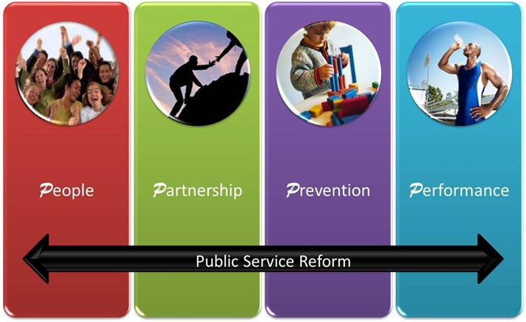
- Prevention - Reduce future demand by preventing problems arising or dealing with them early on. To promote a bias towards prevention, help people understand why this is the right thing to do, the choices it implies as well as the benefits it can bring.
- Performance – To demonstrate a sharp focus on continuous improvement of the national outcomes, applying reliable improvement methods to ensure that services are consistently well designed based on the best evidence and are delivered by the right people to the right people at the right time.
- People – We need to unlock the full creativity and potential of people at all levels of public service, empowering them to work together in innovative ways. We need to help create ways for people and communities to co-produce services around their skills and networks.
- Partnership – We need to develop local partnership and collaboration, bringing public, third and private sector partners together with communities to deliver shared outcomes that really matter to people.

Since 2007 and an SNP Government it is possible to identify three main approaches to structural public sector reform:

- Centralising services into national bodies like Police Scotland and the Scottish Fire and Rescue service.
- Encouraging greater collaboration backed up by powers of ministerial direction. E.g. Health and care integration.
- A hybrid model where services remain locally delivered, but ministers retain policy direction. E.g. community justice.

Structural change is notoriously difficult and expensive. Organisations go into limbo while preparing for it and then spend years sorting out the new structures. In the current financial climate it could be argued that is simply analogous to shifting the deck chairs on the Titanic.

Despite this general aversion to structural change, the SNP manifesto points to a programme for the new government that envisages significant structural change. Reviews are promised of the structure of health boards and councils. This is likely to result in fewer health boards, focusing on acute services as primary care is now run from integrated joint boards.

There is currently a consultation on school governance with the prospects of new regional education bodies with more finance going directly to schools. There are also proposals to allow community councils to run some services and 1% of council budgets devoted to community budgeting. This builds on the Community Empowerment Act provisions that encourage community groups to take over derelict facilities and propose other forms of community engagement in the delivery of services.

With education and social work going elsewhere; leisure and housing has already largely gone arms- length, you are left with rump local authorities. There is a real concern that they could be left to wither on the vine or merged, with decentralisation schemes that give communities a larger say in how the few services that remain are delivered.

Health and care integration

The most significant reform to public services has been health and care integration, which was fully implemented in April 2016.

The new integration model is outlined in the Public Bodies (Joint Working) Act, which permits two broad models. Lead agency and body corporate that brings councils and health boards together in Health & Social Care Partnerships. Everywhere other than Highland have gone for the body corporate model. An Integration Joint Board will run them with at least 3 council and 3 Health board members plus non-voting members from the voluntary sector, trade unions and patient groups. Each board has to develop integration plan (services, budgets) and a three-year Strategic Plan. There will also be Locality Planning Groups below council level. All of these plans have to be approved by the health minister who has extensive powers and will set national outcomes and lead an accountability process. No staff will transfer to the new bodies; they will remain employed by councils and health boards.

There have been many attempts since devolution to encourage better joint working between councils and health boards and few have been completely successful. Workers in health and social care who will have to deliver the planned integration of health and care services in Scotland remain sceptical that this approach will work either. A UNISON survey shows that while many staff believe care integration provides an opportunity to improve services, the impact of budget cuts mean services will get worse.

With considerable justification staff believe that simply moving the managerial deck chairs around will not solve some of the big challenges facing the sector. There is strong international evidence of what works in care integration and the common feature is that it's about people. Sadly, in this whole process that's the bit that has been given the least attention. The focus has been on structures and budgets rather than workforce issues.
The biggest challenge facing the new organisations is social care. The number of patients in hospital who shouldn’t be is roughly the equivalent of the number of beds in Scotland’s newest and biggest hospital – Queen Elizabeth in Glasgow. Demand for social care has also been rising and as a consequence of council cuts most councils have commissioned a race to the bottom in outsourced home and residential care. Wages and conditions have been cut as well as the time allocated to care properly. UNISON’s latest survey of home care staff paints a grim picture. We have now reached a position where many providers are unable to recruit and retain the quality or quantity of staff needed to deliver even a basic service.

The Scottish Government has now allocated additional resources to social care, routed through the NHS to the Integrated Joint Boards. They are committed to ensuring that every care worker is paid at least the Scottish Living Wage, although the funding for this is somewhat opaque. Nevertheless this is a very welcome first step to rebuilding social care. The next step has to be improved training and ensuring that there is time to care as set out in UNISON’s Ethical Care Charter.

Health and care integration is right in principle, but the practice is more challenging and the first priority is to tackle our crumbling social care services.

Community Planning

There are structures that encourage better joint working like community planning. The Scottish Government sees community planning as being a core element of public service reform. The Local Government in Scotland Act 2003 defines this approach:

Community Planning is … a process ... whereby public services in the area of the local authority are planned and provided after consultation and (on-going) co-operation … among all public bodies ... and with community bodies
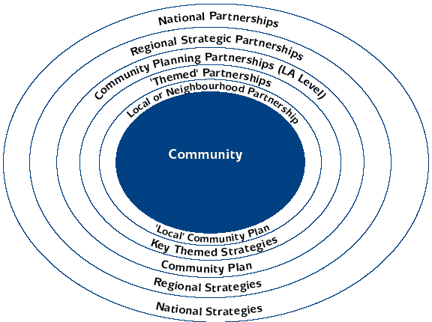
Community planning is delivered through 32 Community Planning Partnerships, led by the local authority, but including all the statutory agencies and third sector representatives. They should draw in community views through a range of consultative mechanisms. Government influences planning through Single Outcome Agreements (SOA) that emphasise the four pillars of public service reform set out above.

Audit Scotland took a detailed look at Community Planning in 2011 and reflected many of the concerns identified by the Christie Commission. They made four general recommendations:

- clarifying the role of CPPs in achieving national outcomes
- the need for better use of data and more consistency in the use of local indicators in SOAs
- the particular challenges associated with managing performance in a partnership context
- the need to resolve the tensions between national and local priorities and between different accountability arrangements.
More work has been done on addressing the weaknesses identified in the report. This culminated in the ‘Community Planning: Turning Ambition into Practice’ report in November 2014. That report identified a renewed energy in the Community Planning Partnerships. However, despite community planning being at the core of public service reform, they found that many CPPs are not clear about what their specific role in these programmes should be. In essence, making progress, but could do better.
Both community planning and care integration highlight the complexity of joint working that Christie sought to promote. These include culture change across institutions and professions; place-based approaches; how to do ‘preventative spend’ and in a period of austerity, the pressures of tight deadlines, budgets and associated short-term thinking.
Digital by default?

Digital services will be an important element of public service reform reflecting developments in the private sector. The Improvement Service has developed ‘myaccount’ that aims to be a simple and secure sign-in service for online public services in Scotland. It has been adopted by City of Edinburgh Council and is integrated with the National Entitlement Card Management System, used for concessionary bus passes and other entitlements.

While digital public services are likely to grow, the slow pace of change reflects the challenges of using these systems in the public sector. Large scale IT projects do not have a good track record in the public sector and many disadvantaged groups who rely of public services still have limited or no access to computers.

This is reinforced in a recent report by the Carnegie Trust on digital exclusion. They found that digital inequalities are most likely to be experienced by those who are more likely to be deprived according to many other measures. Given the pace of digitalisation, including public services, action is needed to ensure that everyone can benefit from these changes.
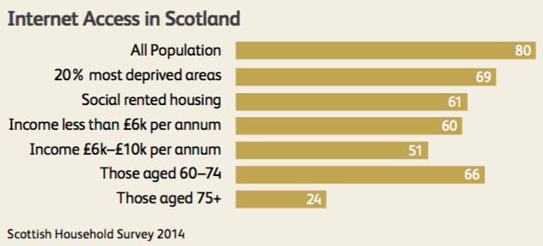
The UK Government has published its digital strategy; described as ‘digital by default’. Again progress has not been rapid. The reasons include, budget cuts, fragmentation, data protection, security, fear of intense scrutiny if things go wrong and problems finding people with the right digital skills. The Scottish Government has a similar strategy ‘Scotland’s Digital Future’.
The European Public Service Union examined the scope and development of public services in the digital age. They argue that digitalisation must not be a mere byword for outsourcing, privatisation and public-private partnerships (PPPs), which undermine the viability of our public services. They found no evidence that the digitalisation or automation of public services will lead to more cost-efficient public services, or will reduce any administrative burden in and of itself. When new ICTs or digital services are implemented without adequate funding or staffing the end results are not only worse services, but also greater costs in the long run as further expenditure is needed to tackle new problems.
UNISON Scotland found some similar concerns in its survey of public service IT staff in Scotland. A common concern was the lack of engagement with IT staff at an early stage. All too often senior managers are mesmerised by the sales pitch and insufficient resources are allocated to ensure projects are delivered effectively.
SOCITM, the professional body for council IT staff has also said that if councils wanted to avoid ‘delusions of transformation’ they needed to change their way of thinking. In a briefing paper they argue that councils need to ‘get serious’ about technology-informed redesign and recognise that real digital transformation goes beyond e-enabling transactions.
Outsourcing and shared services
While outsourcing has not been at the scale seen in England that does not mean that Scotland is exempt from this form of reform. Councils spend over £5.5 billion on goods and services, more than half of that on social care and construction. Other key spends are IT, transport and environmental services. Contract evaluation and monitoring is generally poor. The s52 statutory guidance that sets out the procedures for tender evaluation is widely ignored.

Local government has seen the growing use Arms Length External Organisations (ALEOs). Examples include housing associations and leisure trusts. While there is incomplete data on this the Office of the Scottish Charities Regulator (OSCR) records 64 ALEOs as charities. The smallest has an income of £15,000 and the largest over £110m. There are concerns over the lack of democratic accountability when delivering services through arms lengths bodies. While there are councillors on the boards, their role on a charity (or company) board is clear: ‘the 2005 Act requires trustees appointed to a charitable board by another body to, ‘put the interests of the charity before that body’, if not they have to withdraw from the relevant discussion. OSCR has already raised concerns about role of local authority appointed trustees round this requirement.

Shared services continue to be pushed as the solution to improving efficiency and saving money. Despite numerous high profile failures, and yet another National Audit Office report cataloguing the same issues that occur over and over again across a range of organisations. The key problems remain:

- Initial costs are underestimated because implicit costs and externalities are not included
- Introduction of shared services is complex and costly and requires detailed research
- While some savings are achieved the targets claimed at the outset are rarely achieved
- Where savings are achieved they are mainly from job losses

The Community Empowerment Act is now in place, but we have yet to see how its implementation will impact on public services and communities. There are concerns about further fragmentation of local government services and protection for workers. The Community Ownership Support Service (COSS), has now been given £350,000 for 2016/17, ‘to provide community groups and public bodies with support to transform buildings or land assets.’ Since 2011 there have been 78 asset transfers of buildings or land to local communities.

Encouraging Best Practice

Not all public service reform takes the form of legislation or structural change.

Probably the best example of this is the Improvement Service (IS). The IS works to promote improvement in local government and among its partners to support them to improve outcomes and reduce the outcome gaps within populations and between areas. IS provides consultancy services to councils and others, initially relying overly heavily on external consultants, but in recent years making greater use of secondments. Its main focus has been on developing a range of products that encourage better data analysis using online tools and performance indicators.

Another is What Works Scotland, an initiative to improve the way local areas in Scotland use evidence to make decisions about public service development and reform.

Financing Public Services

The section above on the challenges facing public services sets out the impact austerity economics has had on the delivery of public services in Scotland.

The policy of aiming to produce a balanced public sector budget primarily through cuts has failed dismally. Slashing investment has reduced growth, innovation and productivity, which are all needed by our economy. It also fails to deal the debt caused by the failure of the banking system due to lower tax receipts. This means the starting point of a new approach to the financing of public services has to be the rejection of austerity and a new programme of public investment to rebuild our public services and grow the economy.

While this is primarily a Westminster policy shift, we should also examine what can be done with the powers devolved to Scotland.

Universalism

In 2010, the Scottish Government appointed Crawford Beveridge to undertake an independent budget review. The recommendations were a fairly conventional mix of efficiency savings, pay restraint and rationalising structures. More controversially, the panel questioned protected areas of spending and universality saying:

The principle of universality in the delivery of many of our public services, such as concessionary travel, prescription charges, eye examinations, free personal and nursing care and tuition fees is commendable, but simply may no longer be affordable. A debate needs to be had on whether those who can afford to pay might be invited to do so, thus allowing better targeting of those in most need.

Universalism is often presented in absolutist terms, when in practice the position is more nuanced. Johann Lamont's, admittedly badly crafted, 'something for nothing' speech did not reject universalism. Equally, the SNP's claimed support doesn't extend to access to justice or the charges councils have been forced to levy as a consequence of the regressive Council Tax freeze. In practice, all countries use a mixture of universal and targeted. Unsurprisingly, polling support for universalism tends to be based on the probability of individual benefit.

Universalism doesn’t always deliver the planned policy outcome, for example, the abolition of university tuition fees. As Lucy Blackburn has highlighted, total Scottish student living cost support is very similar to rUK, but is mostly in the form of loans. English students got more grant and as a consequence there is less skewing of debt towards the poor. Scottish graduate debt is therefore regressive as grants fell in real terms to pay for free tuition, the costs of which are fixed. This wouldn't perhaps matter if we could demonstrate a positive impact on better access for disadvantaged groups since the policy diverged from England. However, it hasn’t delivered that outcome - university access in Scotland for disadvantaged groups remains a problem.

The arguments in favour of universalism include the rights based approach and meeting common basic needs. It is also simple with minimal intrusive questions. Against this approach is the need to target limited resources and universalism generally benefits the middle classes disproportionately. In practical terms means testing also increases administrative costs. The recent JRF report on poverty in the UK covers these issues well.

Universalism, balanced by a more progressive taxation system, is the best approach – largely based on the Scandinavian approach. However, political parties in Scotland are reluctant to have the difficult political conversation with the electorate to get us there. Scandamerica, Nordic services on US levels of taxation is simply not achievable. We will therefore be left with a mixed economy of universal and targeted benefits.

In this context we need to look carefully at the interaction between different means tested benefits and with other policies. Otherwise we will end up with an even more chaotic system.

Preventative Spending

There is a broad consensus that Scotland’s public services must focus more on preventing social problems arising rather than reacting to problems once they have occurred. Both the Christie Commission and the Scottish Parliament’s Finance Committee highlighted the benefits of the approach.

The Finance Committee heard evidence every £1 invested in programmes to provide support between the years of birth to age three can save between £3 and £14 later on. More recent work by Dr Jonathan Sher argues that this should be extended to pregnancy.
This graph from the Heckman and Masterov study shows that all things being held constant, the rate of return on a pound of investment made while a person is young is higher than the rate of return to the same pound made at a later age. Following the logic of the Heckman study, attempting to reverse problems in education becomes more expensive the later they are attempted.
Evidencing the long-term benefits of preventative spending can be a challenge. However, we could follow the example of the smoke free legislation, which included a comprehensive evaluation process that is now regarded as world leading.
While almost everyone agrees preventative spending is desirable, delivering it is much more difficult. That’s because decisions have to be made about where disinvestment should occur, or what current services are no longer required in order to achieve the resource shift towards preventative services. For example, probably the two biggest areas of spending that could be shifted are acute hospitals and prisons. However, closing hospitals and prisons are pretty challenging for politicians who have a short term focus and get less political credit for prevention than cures.
Some argue the solution could be the use of Social Impact Bonds. These operate over a fixed period of time and do not offer a fixed rate of return. Repayment to investors is contingent upon specified social outcomes being achieved. They have been used in the UK and the USA, although not without some criticism. Payment by results can lead to contract gaming and real outcomes are rarely deliverable by a single project.
Achieving a spending shift is doubly difficult during austerity. However, it should be a priority for new investment if we are to make the savings in ‘failure demand’ identified by Christie.
Public Private Partnerships and Capital Funding
The search for new ways of funding capital projects has led every Scottish government since devolution to make extensive use of Public Private Partnerships (PPP). This is an umbrella term that includes a range of schemes; the best known is the Private Finance Initiative (PFI). However, it includes the current Scottish Government’s Non-Profit Distributing model (NPD) and the Hub Initiative. While there are some differences between schemes, the essential economics are the same. The private sector borrows the capital then designs, builds and operates the asset.
The attraction for the early Scottish administrations was that these schemes were off the public sector balance sheet, funded by revenue and therefore didn’t count against capital spending limits. A change to the accounting rules makes this more difficult today, but this remains an important incentive for devolved administrations with limited borrowing powers. The downside is that private capital is always more expensive than public borrowing and the long term arrangements (typically 25 years) leave the public sector with inflexible and hugely expensive contracts. Offshore companies based in tax havens now mostly own PPP schemes, so the public sector doesn’t even gain the tax revenues from the profits now often own these contracts.
This infographic from a SPICe analysis of Scotland’s PPP liabilities illustrates liabilities.
The best way to address these ruinously expensive schemes is by using a different form of quantative easing that invests in public assets rather than bank balance sheets, but that would be a matter for Westminster. There are a couple of actions the Scottish Government could take to reduce the cost.
Firstly, every PPP contract should be rigorously monitored to ensure that the contract terms are being delivered. There have been several examples in Scottish health and education schemes were contractors have not transferred savings to the public sector or other contract terms have not been met. There are now initiatives in health and local government to do this. NHS Scotland in particular has established a central unit to do this and is starting to make progress. Overall, much more could be done.
Secondly, the Scottish Government should adopt the plans set out by UNISON Scotland and Neil Findlay MSP to buy out the current contracts. There should be a debt disposal department dedicated to raising funds to buy out the total outstanding debt on operational contracts. Historically low public borrowing rates make this an attractive option and could be financed through the Scottish Government’s additional borrowing powers or through local government prudential borrowing powers. This has been done in England with the Hexham General Hospital PFI, saving £67 million. This was funded by a loan from Northumberland County Council, which borrowed from the Public Works Loan Board (PWLB). On this model a staggering £12bn could be saved on Scottish PPP projects.

The UNISON paper also argues that councils should be making greater use of bonds, for PFI and general borrowing refinancing. The Treasury has been increasing PWLB rates to a level that makes this form of borrowing more attractive. Some 60 local authorities in England have already come together to do this. if half of the outstanding £9 billion of debt of Scottish councils currently with the PWLB was transferred to bonds, the savings could potentially be between £270m and £337.5m over 30 years.

The Scottish Government uses the phrase ‘innovative finance’ to describe its funding schemes that do not use conventional capital. These include using government cash and loan guarantees to leverage private housing investment through the National Housing Finance Trust initiative and the Local Affordable Rented Housing Trust. Tax Incremental Financing (TIF) allows local authorities to fund regeneration and growth from future business taxes that are generated as a result of attracting more businesses into the area because of upfront public sector enabling investment. None of these are as controversial as PPP and are on a relatively small scale.

A much bigger source of funding is City Deals and Regional Partnership Plans. The initiative for these deals came from the UK Government, who along with the Scottish Government is supporting £1.13 billion of investment in the Glasgow and Clyde Valley City Deal. Local authorities estimate that the City Deal will support an overall increase of around 29,000 jobs in the city region and lever in an estimated £3.3 billion of private sector investment over 20 years. Others are expected to follow.

Pension Funds

As highlighted above, limited access to funding for infrastructure investment has led to successive Scottish governments using expensive and inflexible private finance. One huge source of funds that has largely been ignored is local authority pension funds.

The Scottish Local Government Pension Fund (SLGPS) is a funded scheme, unlike NHS, Police, Teachers etc that operate on a pay-as-you-go basis. It is administered by 11 funds with regulations devolved to the Scottish Government. The funds are currently valued at over £34 billion.
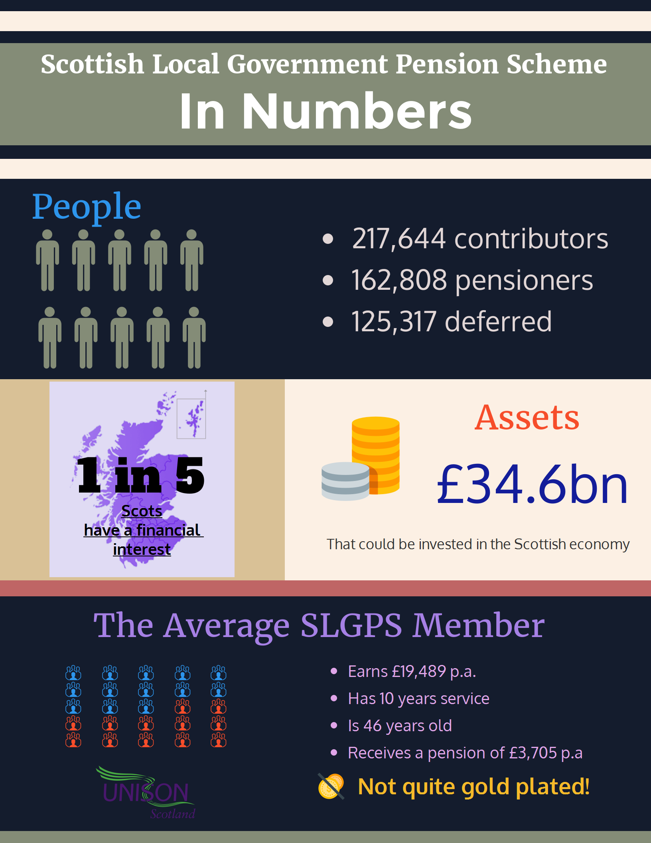
UNISON Scotland has previously suggested that the funds might be invested in infrastructure including housing. UNISON’s report, prepared with assistance from the Scottish Federation of Housing Associations, shows how this could be done.

Based on these ideas, Falkirk Council’s Pension Fund Committee has agreed a £30 million commitment to Social and Affordable Housing in the Edinburgh area. They have also agreed a further £30 million commitment to investment in UK social and affordable housing. Strathclyde Pension Fund has agreed 12 separate infrastructure and related investments with a total commitment value of c £275m.

This is not unique to Scotland. In England the local government minister has decided to double the amount pension funds can invest in infrastructure projects. The Treasury has taken this one stage further by forcing the pooling of investment funds in England and Wales. The aim is to create misnamed ‘British Wealth Funds’. The Scottish Scheme Advisory Board (SAB) recommended abolishing the current investment limits and they have been significantly increased as an interim measure.

A report published by the Smith Institute, Centre for Local Economic Strategies, Pensions Investment Research Consultants and the Local Authority Pension Fund Forum has also highlighted the issue. The research showed that while fund managers said they wouldn’t accept lower returns in exchange for delivering local benefits, it did detect a growing interest in finding new ways to invest generally and in maximising the social, environmental and economic impact of pension funds.

Another quoted constraint is the legal concept of fiduciary duty, particularly when the investment is within the fund’s geographical boundary. UNISON Scotland’s guidance to pension board representatives states that this is all too often interpreted narrowly. The SAB has also issued new guidance to boards on this issue.

The primary duty of a pension fund is to pay member’s benefits. However, within that primary purpose it is possible to make better use of Scotland’s local authority pension funds. In some cases it may require the Scottish Government to underpin investments and relax the regulations. In others, the Scottish Futures Trust could assist in creating suitable investment opportunities outwith their expensive PPP programme. It also requires pension funds them-selves to think outside their current rather narrow approach.

In addition to a new approach to investment, significant savings could be achieved if local authority pensions funds were managed differently. At present huge transaction charges go unreported through the use of external fund managers. There is little evidence that active fund management is any more effective than passive fund management that generates much lower charges. Greater use of in-house staff would also obviate the need for these expensive services.

There are eleven funds in Scotland. This means there is significant duplication and charges to external advisors are being paid several times for the same or similar services. There is evidence that larger funds are more effective and that has driven the UK Treasury pooling approach with funds no smaller than £25bn. If the same approach were applied in Scotland, it would mean one Scottish pooled fund.

Local Government Finance

The funding of local government in Scotland has been a difficult issue for political parties. At best proposals have been sticking plaster solutions because change is viewed as being politically challenging. The latest Commission on local taxation also failed to get cross-party agreement.

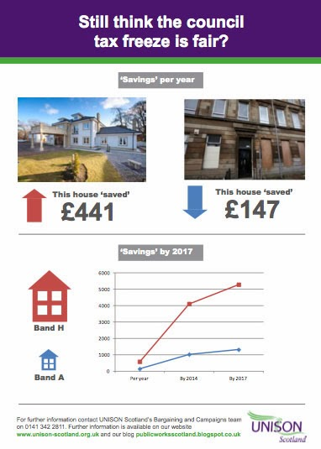
The worst example of sticking plaster solutions is the Council Tax freeze. The freeze was introduced because the Scottish Government’s planned replacement for the Council Tax, a Local Income Tax, crashed. It was later argued that the Council Tax freeze was a contribution to the ‘social wage’ – helping family budgets. While it does that, it does so in a regressive way, giving more support to wealthier householders. Band H households are ‘saving’ on average £441 per year while those in the cheapest homes (Band A) ‘save’ £147 a year.

Councils have partly plugged the gap by increasing charges for services that also hit the lower paid harder. An Audit Scotland investigation confirmed that the income that councils raise from charges has risen over the last decade to £1.3 billion, or approximately 7% of a council’s overall expenditure. That’s equivalent to over 50% of the amount they raise through council tax. And this doesn’t include rents or fines. The proportion of income from charges rose from 5.6% in 2003/04 to 7.4% in 2013.

The Scottish Government has now made the welcome decision that the Council Tax freeze will end next year, although it will still be capped at 3%, undermining local democracy.

The Scottish Government has also published the outline of some reforms to local taxation. The headline is some stretching of the higher bands. Bands A-D are unchanged and the others will increase as follows: band E - £105; band F - £207; band G - £335; band H - £517. This does make the Council Tax more progressive, but it is hardly 'radical'. Stretching the bands was proposed in 2007 and rejected at that time by the SNP. Eight years later, at a cost of £3.15bn to local services, they have come full circle. Importantly, there is no indication that there will be a revaluation of properties, which means properties are allocated to bands based on 1991 property prices. Like a proper reform of the Council Tax, this was presumably put in the 'too difficult' file. Labour made the same mistake in response to the Burt Report in 2007.

There is an outline proposal that councils could have a share of income tax revenues assigned to them. It is difficult to see how assigning revenues makes local taxation more progressive as the government claims. The problem with assigned revenues is that they are largely cosmetic, similar to the Smith Commission plan to assign 10% of VAT revenues to the Scottish Government.

Serious reform of local taxation has to recognise that property is a significant form of wealth and must be taxed in order to reduce inequality. The well-off already own bigger and more houses than the rest of us. If this form of wealth is untaxed it becomes an even more attractive form of investment. This means that more people buy houses, not as a place to live but as an investment. This will add to our already dire housing shortages, increasing prices for both renters and ordinary buyers.

UNISON Scotland has set out five principles for reform:

- Local authorities should raise and control more of their own revenue. This will enable them to respond to and be more accountable to the communities they represent. About 85% of funding is currently determined centrally
- Councils should be able to set their own business rates, this will allow them to raise money to pay for services and devise their own criteria to support the type of businesses they want to encourage.
- A property tax is the best fit for local government as it is clearly linked to the authority. It cannot be moved or hidden making it cheap and easy for the local authority to administer.
- Central government funding should acknowledge local decision making and funds should be minimally ring-fenced.
- Taxation should be broadly progressive, reducing the tax incidence of people with a lower ability-to-pay. It doesn't mean every tax has to be progressive, but overall, those on higher incomes should pay more.

There are other options, although not without their own problems.

A Local Income Tax would be another tax on workers income and ignores the wealth that resides in property. It would have to be administered and set centrally, undermining local democracy. There are also a range of practical problems in collecting and allocating a national tax to local authority areas. It could add as much as 6p to income tax.

Land Value Tax is a superficially attractive option, not least because it is a property tax and might be progressive in taxing the rich. However, this idea has been around for 150 years and there are good practical reasons why it really hasn't taken off. The biggest problem is valuing land while ignoring what is built on it. Most of us have a vague idea how much our house is worth, but not a clue of the land value. In order to send out bills and ensure they are paid you also need to know exactly who owns all the land, where the borders are and where to send the bill. The Scottish Government is working on a register of landowners, but has a timescale of ten years to complete this work. We cannot wait at least another ten years for a new tax. If LVT is part of the solution it is as a central tax that could address issues like land banking, or possibly as a replacement for business rates, but not the Council Tax.

That leaves the option of a Local Property Tax levied on a percentage of actual property values. The Burt Review found that using actual property values rather than banding was more progressive because it would get rid of the ‘cliff edge' where those on either side of a band with a small difference in property values have very different bills. On the other hand banding could reduce appeals. In 2007 he recommended it be set at 1% for same yield as the Council Tax and while this would have created one-third losers, half would be gainers. Any future bills must be based on up to date property valuations and regular revaluations to prevent the current situation building up again.

The new tax would need to have effective mechanisms to protect those on low incomes. Exempting properties below a certain value is one possible way to do this as is the introduction of an appropriate benefit to ensure local authorities received funding, but still protects those on lower wages/benefits. Pensioners with high value properties and low incomes should also be allowed to defer payments, leaving a bill to be paid which would come out of their estate.

Local taxation is one of the most difficult problems for the Scottish Parliament to resolve. No one party wants to be responsible for a new tax. No one wants to pay higher bills, particularly when real wages are not increasing and other costs are rising. Those who get higher bills will campaign loudly against them - winners will quietly carry on. Difficult though it is, we cannot continue without radical change.

Barnett Formula

Despite the increase in financial powers to the Scottish Parliament, the Barnett formula continues to be an important determinant of the level of public spending in Scotland. Under it, extra funding, or cuts, from Westminster are allocated according to the population size of each nation and which powers are devolved.

It can be argued that Scotland has much to thank it for. As former UK government minister Brian Wilson put it:
‘The key to Scotland’s relative wealth and higher earnings is our old friend the Barnett Formula. This year, it provides Scotland with around £10 billion more for devolved spending than we contribute in taxation – equivalent to one-third of the Scottish Government’s entire budget and almost equal to total NHS spending.’

Historically, he has a strong point. It means we spend £1,600 per head more than the average in England or about £8 billion. However, will the Barnett Formula continue to deliver in future?

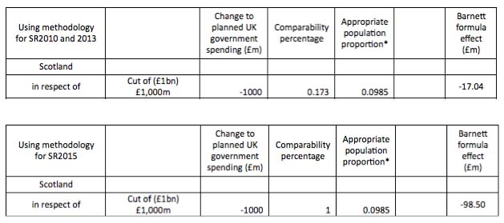
For example, we should be aware of the impact changes in the way local government is funded in England is having on the Barnett Formula. In the 2010 and 2013 spending reviews the Barnett comparability percentage for Local Government was 17.3%, but in 2015 this was changed to 100%. This is mainly down to Non-Domestic Rates payments being devolved to councils. In England, the Local Government budget is being cut over £6bn in the period to 2019/20 and the plan is to end the rate support grant in England by 2020, with further negative consequences for the Barnett formula. This year’s impact on the Barnett formula was more than £80m as shown in this table.

This isn’t a new problem. Since the privatisation of the water industry in England, Scotland hasn’t had any Barnett consequentials for water. This has rarely been significant because there is no real revenue support for Scottish Water – the main benefit of public ownership financially is cheaper borrowing.

The same can’t be said for Higher Education. The reliance on tuition fees in England means negative Barnett consequentials because our universities don’t have that income flow and therefore UK government has been able to cut their contribution to the additional costs.

All of this is because we made different choices in Scotland and that of course is what devolution should be all about. However, that is the potential problem with the Barnett Formula as we go forward. In simple terms, with Barnett we are tied, financially at least, to English public service reform. With a Tory strategy of slashing the size of the state, this has serious consequences for long term funding.

The problem with any discussion of the Barnett Formula is agreeing what should replace it. The most common solution is a needs based formula. However, we have considerable experience of this approach in local government and health board funding and it is rarely without controversy. This is because any needs based formula requires an agreement on what weighting you give to different needs. To take a trite example, a formula based on the percentage of the population with ginger hair would give Scotland a massive financial boost!

Devolved finances

Discussion of the Barnett formula takes us finally to the new powers in the Scotland Act and the fiscal framework. The advantage of controlling more of our own taxation is that we are less beholden to Tory policies in England. However, it also means we need to have grown up conversations about taxation in Scotland and that appears to be equally challenging.

This is not the paper for a full discussion about the finances of constitutional change, although it is important to recognise the challenges the new system creates. The Scottish budget will be made up of the old Barnett formula, less the block grant adjustment, (BGA), plus devolved taxes raised in Scotland. The BGA will grow in line with per capita tax receipts in rUK: so relative per capita spending levels in Scotland and rUK will depend on relative growth rates in Scottish and rUK devolved tax receipts per head. If per capita tax receipts in Scotland grow more slowly than in rUK, we will end up with lower per capita levels of public expenditure than in rUK.

It has been argued that the fiscal settlement locks us into an economic race with rUK and no Scottish government could afford to ignore the consequences of what would happen to relative public expenditure levels in Scotland if we lose out in that race. This could have a significant impact on the extent to which Scottish governments will be willing to implement more progressive tax regimes than in rUK; or radical tax reform; or to devolve major tax decisions to local level.

Whatever the impact of the new powers, we still need to consider how to use them. The problem with an austerity budget is that unless you expand the spending envelope, the debate simply deteriorates into robbing Peter to pay Paul. Any government that is serious about breaking away from austerity economics has to seriously consider using the new taxation powers. Increasing the Scottish Rate of Income Tax (SRIT) by 1p raises around £480m, a not inconsiderable sum.

The reluctance to use the SRIT is in part because of justifiable criticism of the Calman powers. A narrative has developed that, because we can’t have different rates or change the income tax bands, any use of these powers is not progressive. The Calman tax powers are certainly flawed, but that doesn’t mean they are not progressive. As David Eiser from Stirling University explains; ‘the poorest fifth of Scottish households would experience a fall in net income of slightly less than 0.2%, whereas the richest fifth of households would experience income falls greater than 1%. So a rise in the SRIT is slightly progressive’. In any case the bands objection is removed with the latest powers.
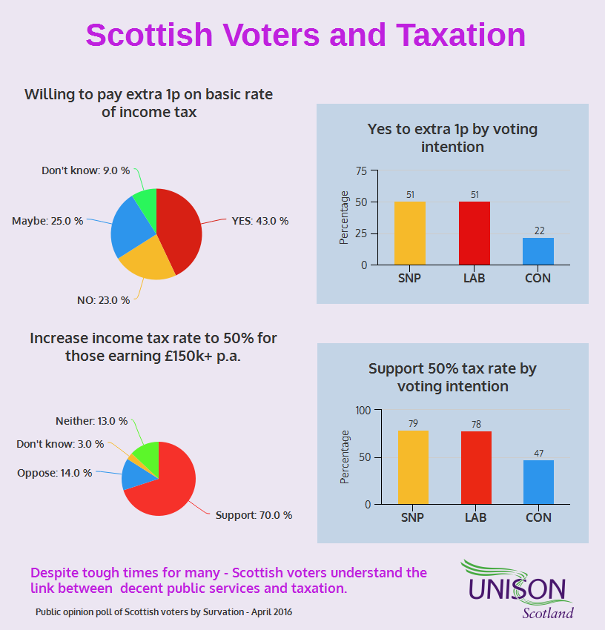
Unsurprisingly, given low wages and a weak economy, no one is dashing to pay more tax. However, in a Survation poll, 43% of voters indicated they would be willing to pay an extra 1p in income tax in order to protect some public services from cuts. A further 25% might be willing and only 23% would not be willing. This is at least a base for an understanding that we cannot have quality public services unless we recognise that most taxpayers will have to contribute to the pot. Interestingly, given their party’s different policy positions on this issue; Scottish Labour and SNP voters had almost identical views on the 1p tax increase; while only 22% of Conservatives indicated a willingness to pay extra tax.

Support for progressive taxation is much stronger when it comes to the highest paid. There was much greater support for a 50% tax rate for those earning over £150k per annum. 70% of respondents supported this, rising to 78% among Scottish Labour voters and 79% among SNP voters. Even a majority of Conservative voters were in favour (47% v 35%).

The new devolved powers have at least started a debate on an issue politicians in Scotland have usually avoided. While no one likes paying more tax, the public does at least appear to grasp that Scandamerica isn’t an option. In addition, public services are a key element in tackling poverty and inequality.

Principles of Public Service Reform

Before considering detailed solution to public service reform in Scotland, we should consider the principles that should underpin those reforms.

Democratic accountability

Democracy is what defines public services in contrast to private sector delivery. It is through democratic accountability, not your ability to pay, that public services should be designed and delivered. Democracy isn’t just about elections for representatives, but about a wider engagement where citizens have meaningful opportunities to input into defining both the problems and the solutions.

Subsidiarity

Ensuring that decisions are taken at the lowest practical level. While it is important to have national standards and guidance, these should not be used to stifle local innovation or local differences. Services should be designed with and for people in communities of place and interest. Co-production and asset based approaches can contribute to this as a positive engagement not simply to manage budgetary cuts.

Transparency

Part of being able to participate in democratic processes is access to the information required to make judgements and hold decision makers accountable. This means accessible data and quality statistical reports. If the third and private sector are delivering public services they too have to be covered by Freedom of Information legislation. Political lobbying also has to be a more transparent and regulated process.

Equality

Public services should be focused on reducing inequalities. This includes preventative spending to reduce demand, tackling the underlying causes of intergenerational deprivation. Services should be funded through progressive taxation that ensures those most able to pay contribute the most. It also means that we should ensure that the less powerful have an equal voice in service design and equal access to services.

Effectiveness

All public service organisations should be working efficiently ensuring they are making the best use of resources. This includes both spending, the skills of staff and appropriate equipment and facilities. It also means avoiding wasteful spending on schemes like PPP.

Public service ethos
There should be a common ethos for all public services and those who deliver them. It is the collective nature of social responsibility that is a defining characteristic of our country. For public service workers this ethos should be based on enabling, empowering and improving the lives of people and communities and well as the traditional values of integrity and openness.
Fair work

People deliver public services and therefore we should aim to recruit and retain the best people to work in our public services, always ensuring that the workforce reflects the diversity of our communities. This requires fair pay and conditions, secure employment and real engagement of trade unions and workers in the decision making process. Workforce development, including a common competency framework, should be a feature of fair work.

Integration

Public service delivery in Scotland, even without large scale marketisation, has become too fragmented. 7,000 care providers are an example of this fragmentation and reform should aim to minimise barriers. While there will always be boundaries between public bodies, these should not be a barrier to co-operation. There should be a common set of powers and duties, ensuring that the piecemeal development of statutory duties and lines of accountability do not hinder cooperation. The single public service worker concept will be important in breaking down organisational and professional silos.

Outcomes

Public services should be focused on achieving outcomes, while recognising that services need the correct inputs and that effective processes matter. They should take a long-term view that should not be disrupted by the short-termism of the political cycle.

New approaches to public service reform

Democracy is not just a question of having a vote. It consists of strengthening each citizen’s possibility and capacity to participate in the deliberations involved in life in society. Fernando Cardoso

The traditional way of viewing the organisation of public services is to start with central government and then consider what powers they should devolve to other national and local structures.

An alternative approach is to start with people and communities and consider what powers are granted up to local government and central government. This is a way of applying the principal of subsidiarity or what the Commission on Local Democracy called ‘sovereignty’. In essence people locally agree to share sovereignty with local, regional and national structures, because that is the most effective way of achieving our collective public service ethos. In the same way we agree, or not, to share sovereignty within the United Kingdom, the European Union, or other international organisations.

This approach doesn’t need to be the same across Scotland. What might make sense in our big cities, might not work in rural areas.

Role of Local Government

The first challenge with this approach is local government. Many of our ‘local’ councils are not local at all. Scotland has the lowest ratio of councils to population in Europe. Despite this scale, services have gradually been removed, starting well before the current Scottish Government’s drift to further centralisation. Councils used to run water, sewerage, energy, further education, police, fire, community care and public health – with a lot less central prescription as well. In large swathes of Europe, local government continues to deliver these services.

This leads to the question of what we mean by ‘local’ or even a recognisable community of place? Is it a street, a village, a town or a city? Again, if we apply the principle of subsidiarity, it is the lowest practical level and that is probably roughly a town and its hinterland. Cities are more difficult to break down into recognisable communities, but it can be done.

Then we can look at what services can realistically be delivered at that level, either standing alone, or with support from specialist or shared services. At this level we can introduce several of the principles above including integration and engagement.

A number of Scottish local authorities have developed area structures to decentralise services and some have tried to integrate the delivery of services in recognisable community settings. This might point the way to a different approach to reform based on community hubs, where all, or most services are physically or, where that is practically difficult, virtually delivered. This creates real integrated delivery, as the Christie Commission recommended, and could include non-council services as well.

Support services like HR, payroll, finance, could be provided off site, without creating unnecessary shared services structures. The aim would be to deal with as many user issues as locally possible, not send them into the failure demand of call centres. With a national workforce framework and the single public service worker, workforce matters would be simplified and not have to be replicated in every hub.

Physically siting services together encourages integration and joint working better than any number of liaison committees or other ways of working. Home care staff that identify health issues with their clients can pop into the GP surgery when they get back to the same base. GP practice nurses can introduce patients to leisure facilities on site and so on. Public service workers who have done this describe how it improves communication and integration better than all the IT systems they have ever had to master, or more usually that simply don’t work.

It also enables the design of services to meet the needs of that community, resolving issues first time. Autonomous working practices are possible, working in small teams, reducing the layers of middle management. There has been significant interest recently in Scotland in the Dutch community nursing Buurtzorg model. This involves nurses/care workers working in small self-managed teams. While it does present challenges, it does show that smaller hub approaches to working could be achieved.

Local service design would benefit from the principles set out in John Sneddon's book Systems Thinking in the Public Sector. He argues that ill thought-out public service reform has led to unwieldy systems of mass production that do little for the people they are supposed to serve. Many services are victims of a dysfunctional regime created by a culture of deliverology that puts targets and red tape before people. He argues we should forget sticking plasters like Customer Relations Management and citizen empowerment and says don't tweak the system. Ditch it. Instead he emphasises the importance of understanding and managing organisations as systems, empowering the managers and staff who understand the value demands users place on services.

Hubs could contribute the joined up preventative work that is so crucial to tackling inequalities. They could include the new generation of children and family centres envisaged in Professor Susan Deacon’s ground breaking 2011 report on early years provision.

They could also encourage a range of community engagement techniques. For example, Lambeth Council has been working with IFS to evaluate different ways to get citizens more involved in the delivery of public services. They asked residents to volunteer to become a ‘Street Champion’ and coordinate efforts to improve the cleanliness and beauty of their local environment. Different types of incentives were randomly offered to different streets to test their additional motivational effects.

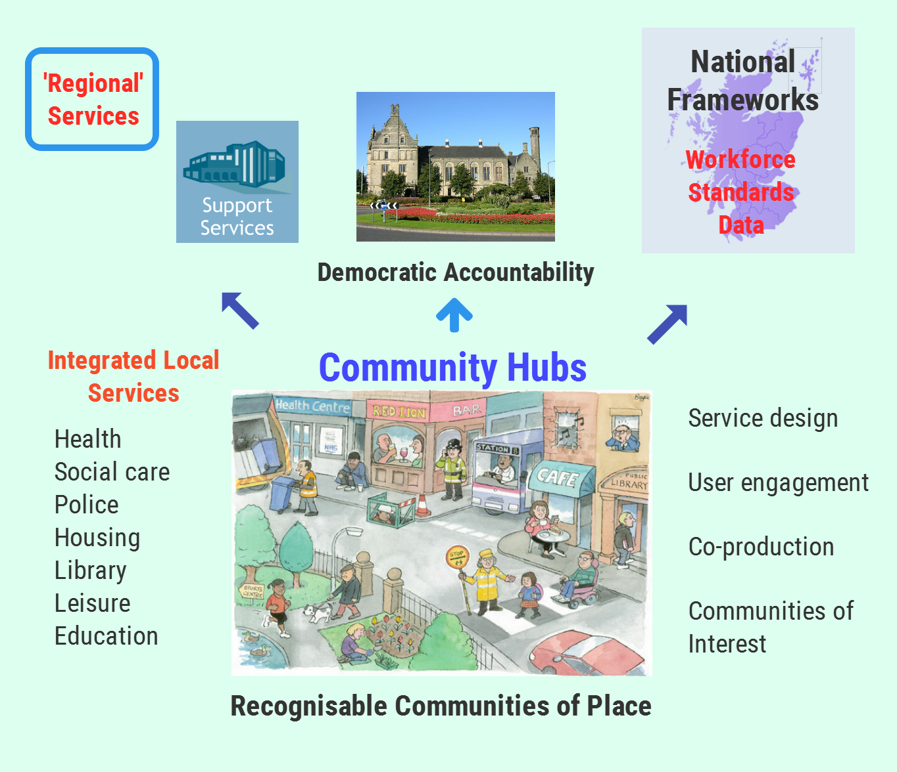
If this is the potential building block for public service delivery, the next question is how are these services democratically accountable?

Some argue that recognisable communities should also be the first tier of local government. The Scottish Liberal Democrats manifesto for the May 2016 elections proposed allowing local communities to establish a burgh council to serve their area, building on the proposals in their earlier 2012 Home Rule Commission chaired by Menzies Campbell.

The current Scottish Government is proposing to allow community councils to run some services, but not on the scale of the hubs above. The Commission on Local Democracy suggested that 60 to 80 unitary councils might be appropriate or as many as 150-200 community governments operating within the current structures.

We can also look elsewhere in Europe, particularly to Scandinavian countries, with a similar population to Scotland, where councils with a population of less than 50,000 operate effectively.

A single tier of local government with many more councils does not mean that specialist services could not be shared. Other services may also benefit from scale. Joint boards or a regional tier of government could deliver these. Again, there are European examples of both models.

The challenges in agreeing the best sub-national governance models are not limited to Scotland. There are a number of initiatives in England and international studies show effective models are those that are not overly bureaucratic; ensure democratic accountability; are responsive to local need and can drive change at the pace and scale required to meet the challenges facing public services today.

The reluctance to consider structural change is understandable. It can have the effect of paralyzing the management of services during the period running up to the restructuring and then taking an equally long period to sort out the new organisation. Some of this could be simplified by national frameworks, but no one should underestimate the disruption and cost involved.

Non-Governmental Bodies

There are a large number of public bodies in Scotland that operate at arms length from the Scottish Government, but have no direct democratic accountability.

The biggest of these is NHS Scotland and its network of regional and national health boards. There was a half-hearted attempt to introduce an element of democracy through direct elections in 2010. There was considerable resistance from the senior health establishment to even this modest injection of democracy and Scottish ministers capitulated to this pressure in 2013.

The Scottish Government is committed to a review of health boards and it is widely anticipated that this will result in a dramatic reduction in numbers. This will give the new health boards an acute focus with community services left in the Integrated Joint Boards.

Another approach is to return to the Christie nod in the direction of all-purpose authorities. Merging councils and health boards would structurally join up services and ensure they were democratically accountable and a bulwark against centralisation. Acute services need to be managed at scale given increasing specialisation, so the realistic option is merging community health services with other council services, including social care. This would also do away with the need for separate Integrated Joint Boards and the associated challenges of managing services and staff that form part of different public bodies.

One country that already does this is Norway. They have small local councils based on natural communities that provide most local services, including community health and care provision. They also have regional councils for strategic functions. Discussions with the Norwegian health unions confirm that this model does provide joined up and democratically accountable services. However, they also pointed out that integration between primary and acute health services did not operate well under this model. This could be a problem in Scotland, as one of the biggest challenges is shifting resources from acute to community services. In essence it appears that wherever you draw the organisational line, integration is challenging.

As with direct elections, there will be significant resistance to this model. Not least because NHS staff are rightly proud of the staff governance model and will be reluctant to swap this for what they will see as a weaker industrial relations model in local government.

Other non-governmental public bodies range from advisory bodies and commissioners to major public corporations like Calmac and Scottish Water. We also have important national services such as Scottish Enterprise, Skills Development Scotland, Food Scotland and SEPA. The much-vaunted ‘bonfire of the quangos’ usually fizzles out or results in cosmetic mergers – demonstrating that there are no simple alternative solutions to providing these services. Relationships between NDPBs and their sponsoring departments can also be challenging. A recent National Audit Office study of English equivalents found that the arm’s-length bodies sector remains ‘confused and incoherent’.

Suggestions that they could be broken up and delivered locally are resisted on the grounds that they allegedly benefit from economies of scale, or are too specialised to spread the limited expertise around the country. Even attempts to minimise duplication by creating common bargaining structures have been opposed by the agencies and government. Options for reform include:
- Identifying parts of the services that could be delivered locally while retaining a national framework on the community justice model.
- Greater scrutiny by parliament.
- Direct elections.
We also have further education colleges that have recently been merged or grouped into regional services with doubtful benefits. Then the much troubled Police Scotland and the less controversial Fire and Rescue Service. As these have all been restructured recently, there will be limited appetite for major structural change.

That does not mean that these services should not be required to cooperate locally more effectively than they current do. This should be delivered through community planning. The Scottish Government is committed to another review of community planning. Progress with the current approach has been challenging as the Audit Scotland review highlights.

Role of the Scottish Government

Few people would disagree with the Scottish Government’s vision for public service reform. Prevention, performance, people and partnership are sound principles and a lot more coherent than the UK government’s contradictory tight-loose model, supplemented by the ideological marketisation of public service delivery.

The problems arise in the consistent application of these principles and the absence of any guiding principles for how this translates into delivery. The Scottish Government centralises police and fire one year and then talks about empowering schools and decentralising power to communities the next.

The commonly accepted role of central government is to set minimum standards for a range of services. There are those who argue that the government cannot guarantee a minimum unified standard, although even local government organisations generally accept that this is a valid role for government. The case for minimum standards is arguably stronger in a relatively small country such as Scotland.

The case for minimum standards does not justify prescription. For example, at one stage the UK government had over 1200 performance indicators for English local government. In Scotland, there has been a fine line between minimum standards and prescription; with the use of ring fenced council budget allocations for teacher numbers, police numbers and the Council Tax freeze.

Most statutory services give Scottish ministers the reserve power to direct public bodies and these have increased in recent years. For example, the Public Bodies (Joint Working) Act 2014, which established integrated joint boards to deliver health and care integration, has an huge array of powers to allow ministers to direct every aspect of the service.

Prescribing how services are managed could be justified in the case of health boards and NDPBs because these organisations have only limited local democratic accountability. However hard ministers might wish to deflect operational complaints, they are accountable to parliament for these services. Such interventions are far less justified in relation to local government that has its own democratic mandate.

The Enabling State and Participatory Budgeting

The problems faced by New Localism in the last UK Labour administration, or abusing the language of co-operation by the current UK government - does not mean localism has gone away as a credible concept.

For example, there is the concept of the Co-operative Council. The City of Edinburgh Council describes itself as such and is part of the Co-operative Councils’ Innovation Network, a collaboration between local authorities committed to transforming the way they work with communities. This is a much wider concept than simply mutuals as a service delivery organisation. It builds on the traditions of the co-operative movement to encourage collective action, co-operation and empowerment.
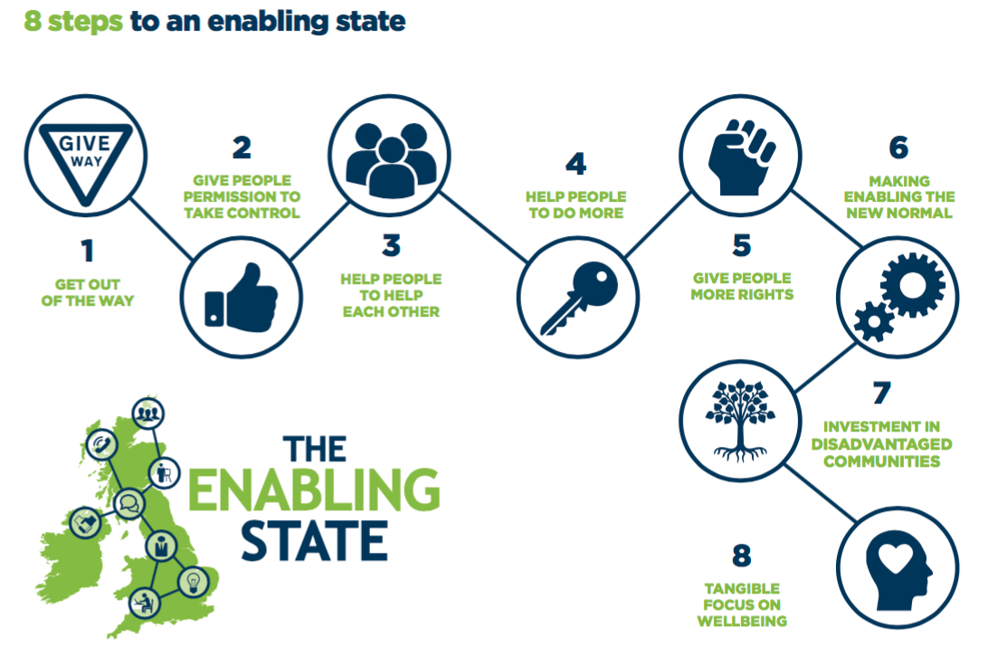
The Carnegie Trust started a project in 2012 it calls ‘The Enabling State’. The name is unfortunate, given the similarity to Nicholas Ridley’s infamous ‘Enabling Council’ leaflet, but the concept is different.

They argue that we need to rethink the relationship between the state and communities and citizens, with the state playing a facilitative and enabling role. They have funded a number of local initiatives to illustrate the concept in practice. Almost all of these projects identify a connection with the state. ‘Getting out of the way’ doesn’t mean rolling back the role of the state.

Another form of citizen empowerment is personalisation. The Social Care (Self-directed Support) (S) Act came into effect in April 2013. It gives options for people assessed as being eligible for support. They can have a direct payment and employ their own carers, often through an agency, or ask the council to provide the support using their personal budget. It is argued that this allows people to take control and make the big decisions that affect how they live their lives. Critics argue that it is simply a means of passing on the cuts, undermining collective provision and causing isolation, particularly for the elderly.

A more radical form of engagement is Participatory Budgeting (PB). This presents the opportunity for elected representatives to work more closely and collaboratively with citizens to develop new and innovative solutions to economic policy, and in handing over money as well as responsibility to citizens to vote on such models. This is rapidly becoming a global movement including cities such as New York, Seville, Toronto and Paris. Portugal has recently announced a participatory budget on a national scale.

In Scotland, £1.75 million has been invested in PB projects with the average expenditure being £28,400 per PB process. At least 179 individual projects have been funded via PB, allocating on average £9,300 per project, with most PB taking place in disadvantaged areas.

However, the first review report also uncovered little evidence of PB processes featuring substantial opportunities for public dialogue and deliberation between participants. It also highlights a lack of information and evaluation on existing PB processes, and finds few examples of PB happening in rural areas. Effective deliberative participatory budgeting processes have allowed citizens to understand the needs of other areas and individuals as much as their own, and to think about how to create a better, more inclusive local economy, not just for themselves but for everyone.

Municipal enterprise and local economies

Traditional approaches to local economic development have focused on top down, the ‘centre knows best’ plans. These approaches place a focus on attracting large firms to an area, businesses that have few connections to the locality, and are often to the first to flee when the economic cycle shifts. Large amounts of public money have been poured into some areas in the hope that it will trickle down to the people who live there - when in practice much of that money didn’t stay there.

In a UK context, we often talk about the north-south divide. Scotland is territorially divided, but in a more complex and unequal way. 14.2% of the population in Scotland lives in locally failed economies compared with 4.2% in the UK. 29.3% live in the three urban centres dominated by affluence, compared with 11.2% in the UK. These localities are often situated close to each other – disadvantaged communities living near affluent ones. This has implications for how we approach local economies in Scotland.

There are important new approaches to local economies such as the New Economics Foundation (NEF) ‘Plugging the Leaks’ and the CRESC manifesto for a Foundational Economy, which are explored in the Red Paper publication on Progressive Federalism. These ideas point to a very different approach to economic development in Scotland.

Councils already play an important role in economic development. They provide the essential infrastructure in every community. From education, skills, transport and planning through to practical business support including gateway advice and grants. Councils should promote local supply networks, social enterprise and co-operatives, all of which are less likely to leak resources from disadvantaged areas.

The NEF pilots also pointed to the imaginative use of local procurement. They found that sometimes councils can't find local contractors for jobs and have to tender competitively. But working with local residents and community groups they can come up with creative solutions. These include informing local people well in advance of a new contract so they can strengthen their bid, or encouraging outside contractors to train up local people on the job.

Councils should stop judging the efficiency of the spend solely against the service or product procured. Instead we should focus on how much that spend stimulates the local economy. We also need to judge how far each measure promotes greater equality. That means specifying the Scottish Living Wage, not awarding contracts to blacklisting or tax dodging companies and other positive procurement polices.

We shouldn’t limit the role of councils just to procurement. A range of services could be delivered using municipal enterprise. These include community energy schemes that not only act as a retailer of energy, but also generate electricity and promote energy efficiency. Bus re-regulation would not only tackle the poor management, cost and declining use of buses in Scotland, but could lead to municipal transport organisations leading a low carbon transport revolution across the country.

Conclusion

The virtuous citizen must be free, but not simply free to go his or her own way. Instead the citizen is free when he or she participates in the government of his or her community. (Richard Daggers 1997)

The above quote illustrates what should be the starting block for public service reform in Scotland. We should build public services around recognisable communities. As far as practicable, they should be physically integrated to break down silo working. However, pure localism, especially when driven by market mechanisms, simply leads to fragmented service delivery that wont challenge the underlying inequalities that blight our country and waste public resources, generation after generation.

The level at which services are delivered should be driven by the principle of subsidiarity – the lowest practical level. They should allow staff and citizens to design services in a way that best meets the needs of their communities of place and of interest. Not in a vacuum, but informed by best practice and open to the sort of ideas discussed by co-operative councils, the enabling state and systems thinking.

While structural reform is always a last resort, we should be open to considering what structures best support communities, optimise support/strategic services and most importantly, ensure democratic accountability. We should recognise that the public sector landscape in Scotland is probably overcrowded.

The role of central government should be to set the strategic direction based on outcomes – rather than trying to direct services from Edinburgh. However, a country the size of Scotland cannot justify duplication and difference for the sake of it. Government should agree frameworks that allow the local to focus on what matters. This should include a public sector ethos and fair work principles embodied in a national workforce framework. The single public service worker could minimise organisational and professional barriers and provide confidence for staff to engage in service redesign.

This approach is neither centralism nor localism. It offers a co-operative more equal Scotland, rather than one left to the vagaries of the market. Who knows, Scotland may even become the go to place for effective public service reform in a small country.

References Christie Commission on the Future Delivery of Public Services – June 2011. http://www.gov.scot/resource/doc/352649/0118638.pdf
OECD (2011), Divided We Stand: Why Inequality Keeps Rising www.oecd.org/els/social/inequality
Survation Poll – March 2016 http://publicworksscotland.blogspot.co.uk/2016/04/scottish-parliament-elections-its.html
Draft Scottish Budget 2016/17 http://www.gov.scot/Publications/2015/12/9056/0
Impact of Austerity on Scotland – April 2016. http://www.unison-scotland.org/library/ImpactofAusterityonScotland_April2016.pdf
The Cost of the Cuts: The Impact on Local Government and Poorer Communities, March 2015.
Centre for Health Economics – April 2016 https://theconversation.com/if-you-think-the-nhs-is-going-to-receive-an-extra-8-4-billion-think-again
Scottish Parliament Finance Committee – Preventative Spending – 2011 http://archive.scottish.parliament.uk/s3/committees/finance/reports-11/fir11-01.htm
Scotland and Brexit - http://unisondave.blogspot.co.uk/2016/09/scotland-and-brexit.html
Why trade deals are bad for our health - http://unisondave.blogspot.co.uk/2016/10/why-trade-agreements-are-bad-for-our.html
http://www.unison-scotland.org.uk/response/PublicBodiesJointWorkingBill_evidencetoHealth+SportCttee_Aug2013.pdf
Scottish Social Service Council 2016 annual report - http://www.sssc.uk.com/about-the-sssc/multimedia-library/publications/37-about-the-sssc/2016-a-trusted,-skilled-and-valued-social-service-workforce
http://www.unison-scotland.org/campaigns/public-works/damage/
http://www.unison-scotland.org/2016/08/16/home-care-workers-ask-we-care-do-you/
http://www.unison-scotland.org/2016/03/23/unison-welcome-ippr-scotland-report-scotland-pay-packets-down-12-in-real-terms-since-2009/
http://www.fairworkconvention.scot/
Gregor Gall ‘Failure of the Fair Work Framework’: Reid Foundation 2016 http://reidfoundation.org/2016/04/failure-of-the-fair-work-framework/
Three paradigms of public service reform – Barber 2007 www.mckinsey.com/~/media/...service/Public%20Sector/.../TG_three_paradigms.ashx
UK Government’s approach to public service reform – 2006 webarchive.nationalarchives.gov.uk/...gov.../public_service_reform/sj_pamphlet.pdf
Systems Thinking in the Public sector – Seddon 2008
History Politics and Vulnerability: explaining excess mortality GCPH 2016 http://www.gcph.co.uk/publications/635_history_politics_and_vulnerability_explaining_excess_mortality
Public Value: Next steps in public service reform – Work Foundation 2008 http://www.theworkfoundation.com/assets/docs/publications/201_pv_public_service_reform_final.pdf
People Shaped Localism – RSA https://www.thersa.org/action-and-research/rsa-projects/public-services-and-communities-folder/people-shaped-localism
Mutual Benefit? – Steve Davies https://www.unison.org.uk/content/uploads/2013/06/On-line-Catalogue199463.pdf
Scotsman: ‘How much money do charity bosses earn?’ - 21 January 2016
Public Administration Committee report: The collapse of Kids Company: extraordinary catalogue of failures https://www.parliament.uk/business/committees/committees-a-z/commons-select/public-administration-and-constitutional-affairs-committee/news-parliament-2015/kids-company-report-published-15-16/
Social care crisis – Third Force News July 2016 http://thirdforcenews.org.uk/tfn-news/charities-must-merge-and-curb-senior-management-pay-to-weather-funding-stor
IPPR: ‘Too Small to Fail’ – Feb 2016. http://www.ippr.org/publications/too-small-to-fail
Martin Sime - The third sector must take back control http://thirdforcenews.org.uk/blogs/brexit-the-third-sector-must-take-back-control
As above.
Commission on the Future Delivery of Public Services – June 2011 http://www.gov.scot/resource/doc/352649/0118638.pdf
Total Place: Practitioner’s Guide http://www.leadershipcentre.org.uk/totalplace/news/total-place-a-practitioners-guide/
Independent Budget review Panel report – Scottish Government July 2010 http://www.gov.scot/About/Review/IndependentBudgetReview
NHS Scotland a role model for reform – Nottingham University 2012 https://www.nottingham.ac.uk/news/pressreleases/2012/february/nhs-scotland-a-role-model-for-reform,-says-study.aspx
See national public bodies directory for numbers, budgets and staffing numbers. http://www.gov.scot/Topics/Government/public-bodies/about/Bodies
Voices from the Sharp End – UNISON Scotland Oct 2014 http://www.unison-scotland.org.uk/socialwork/CareIntegrationSurvey_UNISONScotlandReport_Oct2014.pdf
‘We Care, Do You?’ – UNISON Scotland July 2016. http://www.unison-scotland.org/library/WeCare_DoYou_UNISONCareWorkersSurvey_August2016.pdf
Briefing: Ethical care Charter – UNISON Scotlabd Jan 2016. http://www.unison-scotland.org.uk/briefings/b070_BargainingBrief_EthicalCareCharter.pdf
Community Planning Partnerships – Audit Scotland Nov 2011. http://www.audit-scotland.gov.uk/docs/central/2011/nr_111103_community_planning.pdf
‘Community Planning: Turning Ambition into Practice’ Audit Scotland November 2014. http://www.audit-scotland.gov.uk/docs/central/2014/nr_141127_community_planning.pdf
My Account - http://www.improvementservice.org.uk/myaccount.html
Digital participation and social justice in Scotland – Carnegie Trust – Sept 2016 http://www.carnegieuktrust.org.uk/carnegieuktrust/wp-content/uploads/sites/64/2016/09/v3-2697-CUKT-Digital-Participation-summary.pdf
‘Government Digital Strategy’ – Dec 2013 https://www.gov.uk/government/publications/government-digital-strategy
Scotland’s Digital Future – Sept 2012 http://www.gov.scot/Publications/2012/09/6272
Smart Public Services for a Digital Age: EPSU April 2016. http://www.epsu.org/sites/default/files/article/files/EPSU%20position_Smart%20Public%20Services%20in%20the%20Digital%20Age%2016.04.19-20%20-%20EN.pdf
Disconnected – UNISON Scotland – Nov 2015 http://www.unison-scotland.org/2015/11/30/disconnected-ict-staff-survey-nov-2015/
Changing the game – SOCITM – August 2016 https://www.socitm.net/publications/briefing-92-changing-the-game-the-systemic-failure-of-transformation
National Audit Office shared services centre May 2016 https://www.nao.org.uk/wp-content/uploads/2016/05/Shared-services-centres.pdf
What Works Scotland - http://whatworksscotland.ac.uk/the-project/
Report of the independent budget review panel – 2010 http://www.gov.scot/Publications/2010/07/29082838/2
As above.
Scottish Parliament Education Committee inquiry - http://www.parliament.scot/S4_EducationandCultureCommittee/Inquiries/SSLucyHunterBlackburn.msg.pdf
Counting the Cost of UK Poverty – JRF August 2016 https://www.jrf.org.uk/report/counting-cost-uk-poverty
Scottish Parliament Finance Committee 2011 http://www.parliament.scot/newsandmediacentre/24570.aspx
‘Prepared for Pregnancy?’ – Dr Jonathan Sher 2016. http://www.nhsggc.org.uk/media/237841/prepared-for-pregnancy-j-sher-may-2016.pdf
Skills Policy for Scotland 2004 – Heckman and Masterov. University of Strathclyde
Smoke Free legislation – NHS Health Scotland http://www.healthscotland.com/scotlands-health/evidence/smokefreelegislation.aspx
Social Finance UK http://www.socialfinance.org.uk/about-us/
Revenue-financed investment:the size of Scotland’s PFI and NPD liability – April 2014 http://www.parliament.scot/ResearchBriefingsAndFactsheets/S4/SB_14-29.pdf
Combating Austerity – UNISON Scotland http://unison-scotland.org.uk/publicworks/CombatingAusterity_Sep2015.pdf
Funding and Building the Homes Scotland Needs – UNISON Scotland March 2013. http://www.pensionsscotland.org/uploads/3/9/5/5/39556225/fundingandbuildingthehomesscotlandneeds_mar2013.pdf
Local Authority Pension Funds – Sept 2012 http://www.smith-institute.org.uk/book/local-authority-pension-funds-investing-for-growth/
Fiduciary Duty – UNISON Scotland Sept 2015 http://www.pensionsscotland.org/uploads/3/9/5/5/39556225/fiduciary_duty_briefing.pdf
Commission on Local Tax Reform – Final Report Dec 2015 - http://localtaxcommission.scot
Charging for Services: Are you getting it right? – Audit Scotland Oct 2013 http://www.audit-scotland.gov.uk/docs/local/2013/nr_131031_hcw_charging_services.pdf
Council Tax Reform – March 2016 http://news.scotland.gov.uk/News/Council-tax-reform-2347.aspx
Paying For Local Government – UNISON Scotland. http://www.unison-scotland.org.uk/localgovt/PayingforLocalGovernment_UNISONdiscussionpaper_Nov2013.pdf
A Fairer Way – 2006 http://www.gov.scot/Resource/Doc/153766/0041377.pdf
Fiscal Deal Woes – Jim Cuthbert – Reid Foundation January 2016 http://reidfoundation.org/portfolio/fiscal-deal-woes/
SRIT – Progressive or Regressive? – David Eiser Jan 2016 http://www.centreonconstitutionalchange.ac.uk/blog/scottish-rate-income-tax-progressive-or-regressive
Commission on Local Democracy – COSLA 2014 https://issuu.com/cosla/docs/final_report_august_2014
UNISON Scotland Briefing 72 - Buurtzorg http://www.unison-scotland.org/2016/01/28/briefing-072-bargaining-buurtzorg-care-model-jan-2016/
Systems Thinking in the Public sector – Seddon 2008
Joining the Dots – Susan Deacon March 2011 - http://www.gov.scot/Resource/Doc/343337/0114216.pdf
An evaluation of different ways to incentivize citizens to co-produce public services in Lambeth – IFS July 2016 https://www.ifs.org.uk/publications/8352
Home Rule Commission – October 2012 http://www.libdemvoice.org/scottish-liberal-democrats-launch-vision-of-federal-uk-home-rule-and-local-empowerment-30834.html
Learning the lessons from international models of sub-national governance – LGA 2016 http://www.local.gov.uk/documents/10180/7632544/3.2+English+devolution_06-WEB.pdf/24c5a48b-744c-4ba4-8736-2277d9fa6e67
Minister capitulates to establishment on health board democracy - http://shascotland.blogspot.co.uk/2013/11/minister-capitulates-to-establishment.html
Scottish Public Body Information - http://www.gov.scot/Topics/Government/public-bodies/about
Departments’ oversight of arms length bodies: a comparative study – NAO July 2016 https://www.nao.org.uk/report/departments-oversight-of-arms-length-bodies-a-comparative-study/
Community Planning Update – Audit Scotland 2016 http://www.audit-scotland.gov.uk/uploads/docs/report/2016/nr_160303_community_planning.pdf
Professor George Jones in evidence to HofC Public Administration Committee (s90) https://www.publications.parliament.uk/pa/cm200809/cmselect/cmcomloc/33/33i.pdf
Co-operative councils innovation network - http://www.councils.coop
Enabling state in practice – Carnegie Trust 2016 http://www.carnegieuktrust.org.uk/carnegieuktrust/wp-content/uploads/sites/64/2016/08/LOW-RES-2660-Enabling-State-in-Practice.pdf
Personalisation in Scotland – The Facts http://www.unison-scotland.org.uk/socialwork/Personalisation_01_2012.pdf
Participatory Budgeting Network https://pbnetwork.org.uk
Review of participatory budgeting in Scotland - https://pbscotland.scot/blog/2016/10/19/review-of-participatory-budgeting-in-scotland
Progressive Federalism – Red Paper Collective April 2016. http://redpaper.net/wp-content/uploads/2016/04/pdf-red-paper.pdf

